Potential Local Heritage Assets
- Selection Criteria
Selection criteria have been adapted from those used by HBBC to allow easy mapping from the Neighbourhood Plan to the HBBC list when/if necessary.

Why is it locally valued?
Historic It is important to understand an association with a person, event, episode of history, local industry, or social, economic, cultural, or religious development of the area. This might be an illustrative interest (it illustrates an aspect of the area’s past that makes an important contribution to its identity or character), and/or an associative interest (it connects us to people and events that shaped the identity or character of the area).
Evidence It is an important resource for understanding and learning about the area’s history, enhanced by a significant contemporary or historic record (written, drawn or oral). This might include archaeological interest (it will be the primary source of evidence about the substance and evolution of the area and the people and culture that made it).
Aesthetic It makes an important contribution to the area because of its design (planned or fortuitous), construction, craftsmanship or decoration. This might be architectural interest (it is a high-quality representation of an architectural period or style, a building of particular use, a technique of building, the use of material, or be the works of a particular important architect or company), and/or artistic interest (it includes artistic endeavour to communicate meaning or use of design (including quality landscape design) to enhance appearance).
Includes the Historic England national criteria of Representativeness. May be representative of a particular architectural period, architect, movement, company, or group of its time, for example Quaker, railway, Victorian and industrial.
Includes the Historic England national criteria of Artistic Interest. An asset with artistic interest exhibiting some degree of creative skill (including sculpture, painting, decoration, advertisements, memorials, gates, railings, door surrounds, finials and signage).
Community It is perceived as a source of identity, distinctiveness, social interaction, and cohesion, contributing to the ‘collective memory’ of a place. This might include commemorative or symbolic interest, that reflect meanings of a place for people who relate to it. It is important to all or part of the community. It has a social value and may be a source of civic pride.

What makes its local significance special?
Age Is it particularly old, or of a date that is significant to the local area? This should consider local characteristics distinctive to the type of asset.
Rarity Is it unusual in the area or a rare survival of something that was once common? For an asset to have a degree of rarity it must exemplify a design, age, pattern, or other quality that is in itself uncommon, either to the locality, borough or wider region. Many assets for example may be of considerable age but may not be particularly rare.
Integrity Is it largely complete or in near to original condition? To have a degree of integrity the asset should retain a sense of completeness either individually or part of a larger group. The interest of an archaeological site will depend on its level of survival, and those assets which demonstrate the greatest potential for archaeological interest will be considered for inclusion on the list if the evidence base is compelling and a distinct area can be identified.
Landmark Quality Does it have a visual prominence, and can it be singled out as a landmark within the local scene? Assets considered a ‘local landmark’ are normally aesthetically attractive and dominate the street scene or an important view or vista. An asset with landmark quality is normally seen as a geographical or cultural orientation point.
Includes the Historic England national criteria of Townscape or Landscape Value. Key landmark buildings or structures and buildings that strongly contribute to a view or roofscape vista. Valued open spaces (including designed landscapes, streets, squares, parks, gardens, amenity and green spaces), walls, fences, railings, street surfaces (including cobbles, setts and grass verges). Street furniture (including signpost, streetlights, benches, post boxes and telephone boxes.
Group Value Is it part of a group of assets that have a clear historic, aesthetic, or communal association? This relationship can be the result of a deliberate design or accidental, through piecemeal development of the area.
Other Is there another way you think the asset has a special local value or interest?
- Other attributes

Asset Type
Usually, a building or group of buildings, but could also be a monument, site, place (street, park, garden, natural space), landscape (an area defined by visual features or character, e.g., a city centre, village, suburb, or field system).

Sources
The significance of the asset may be informed by a significant written record, for example the Historic Environment Record and published articles. If the asset was identified in the conservation area appraisal, this will help justify inclusion as a local heritage asset, but it does not necessarily mean that it is already listed somewhere.
- Ratby Road
  - 2-4 Ratby Road
2-4 Ratby Road
Address | 2-4 Ratby Road, LE6 0GG |  | 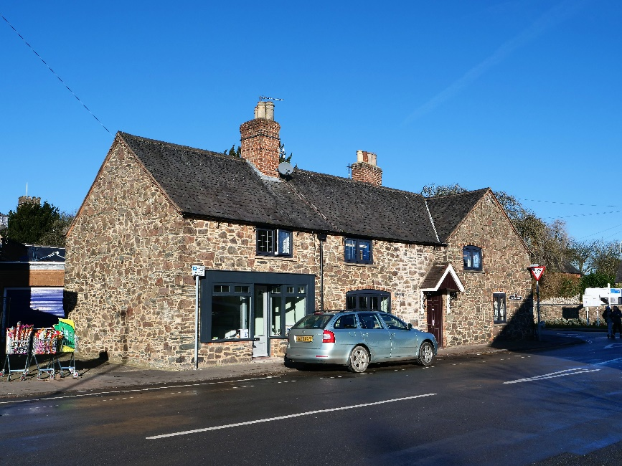
Grid Ref. | 452392, 307527
Asset Type | Building
Age | Unknown
Conservation Area | Yes
Selection Criteria
Value: Historic, Aesthetic-Architectural Interest
Significance: Landmark Quality, Group Value (Stone and slate construction, other historic buildings nearby, 1925 sale)
Description
These properties are in the heart of the village and in all probability began life as single room units i.e., with no upper floors.
Reason for Inclusion
Vernacular architecture including a Groby slate roof with the chimney stack adding to the character of the building. The location of these houses near to the Earl of Stamford Arms Grade II listed building and to the Butchers Shop at the junction of Ratby Road, Markfield Road and Leicester Road contributes to this important street scene in the conservation area.
Sources
- Identified as an unlisted building of local historic or architectural importance in HBBC Conservation Area Appraisal 2010.
- Nominated by David Ramsey 2022.
- Lot 115 in 1925 sale.
- Nominated by respondents (4) to the community survey March 2022 as a building of local historic and aesthetic importance.
- There is a building at this location on the following OS maps although the frontage to Ratby Road is different to that of today:
  - OS Six Inch 1885 (Surveyed 1885) Leicestershire Sheet XXX. N.E.
  - OS Six Inch 1904 (Surveyed 1901) Leicestershire Sheet XXX. N.E.
  - OS Six Inch 1919 (Surveyed 1914) Leicestershire Sheet XXX. N.E.
  - OS Six Inch 1930 (Surveyed 1928) Leicestershire Sheet XXX. N.E.
Notes
- Main photograph by Andy Lincoln January 2022.
Additional Photographs
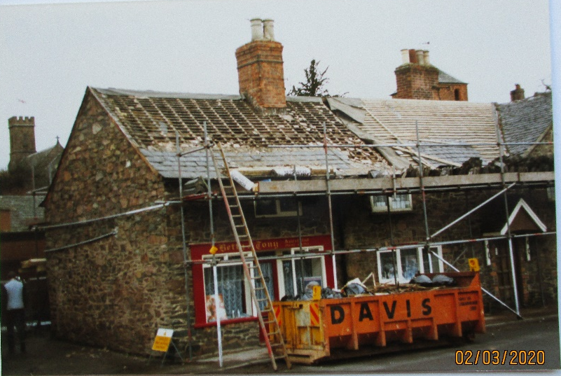 |  | 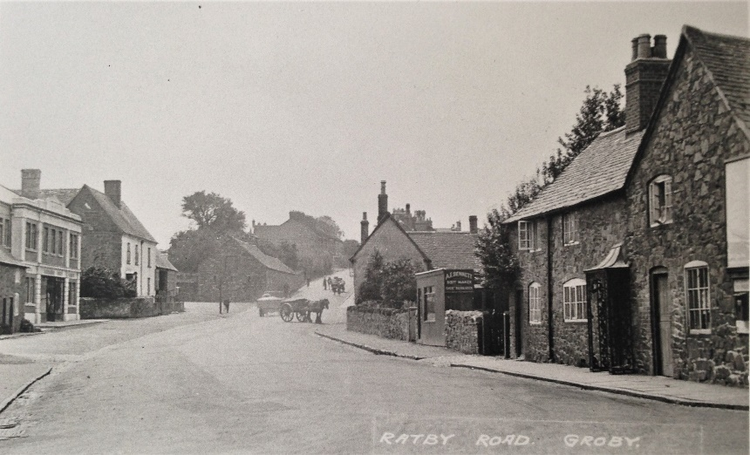

  - 11-15 Ratby Road
11-15 Ratby Road
Address | 11-15 Ratby Road, LE6 OGF | 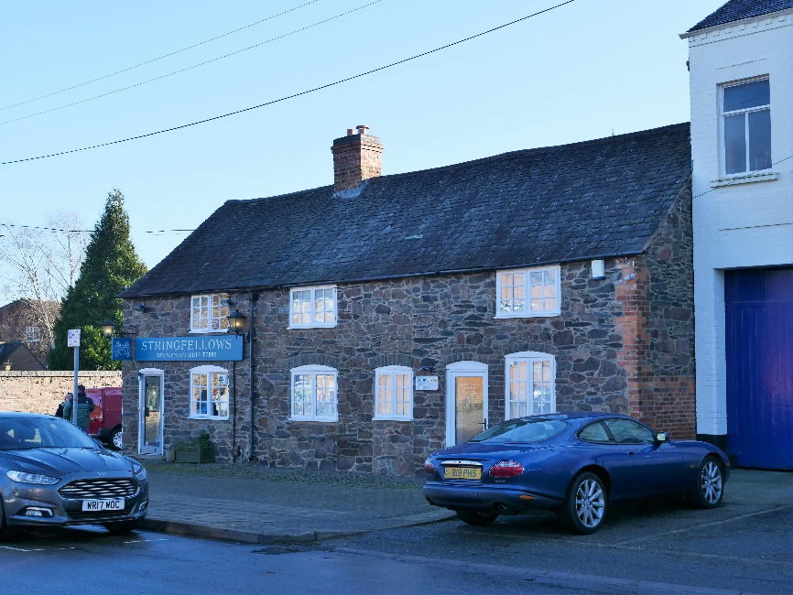
Grid Ref. | 452387, 307481
Asset Type | Building
Age | Unknown
Conservation Area | Yes
Selection Criteria
Value: Historic, Aesthetic-Architectural Interest
Significance: Landmark Quality, Group Value (Stone and slate construction, other historic buildings nearby, 1925 sale)
Description
The cottages are simplistic in their design and choice of raw materials. They have Groby slate roofs from Bradgate Hill, Groby.
Reason for Inclusion
Contributes to the village centre street scene in the conservation area.
Sources
- Identified as an unlisted building of local historic or architectural importance in HBBC Conservation Area Appraisal 2010.
- Appears in ‘A Guided Tour’ by Groby Village Society.
- Nominated by David Ramsey 2022.
- Lot 129 in 1925 sale.
- Nominated by respondents (1) to the community survey March 2022 as a building of local historic and aesthetic importance.
- There is a building at this location on the following OS maps:
  - OS Six Inch 1885 (Surveyed 1885) Leicestershire Sheet XXX. N.E.
  - OS Six Inch 1904 (Surveyed 1901) Leicestershire Sheet XXX. N.E.
  - OS Six Inch 1919 (Surveyed 1914) Leicestershire Sheet XXX. N.E.
  - OS Six Inch 1930 (Surveyed 1928) Leicestershire Sheet XXX. N.E.
Notes
- Main photograph by Andy Lincoln January 2022.
Additional Photographs
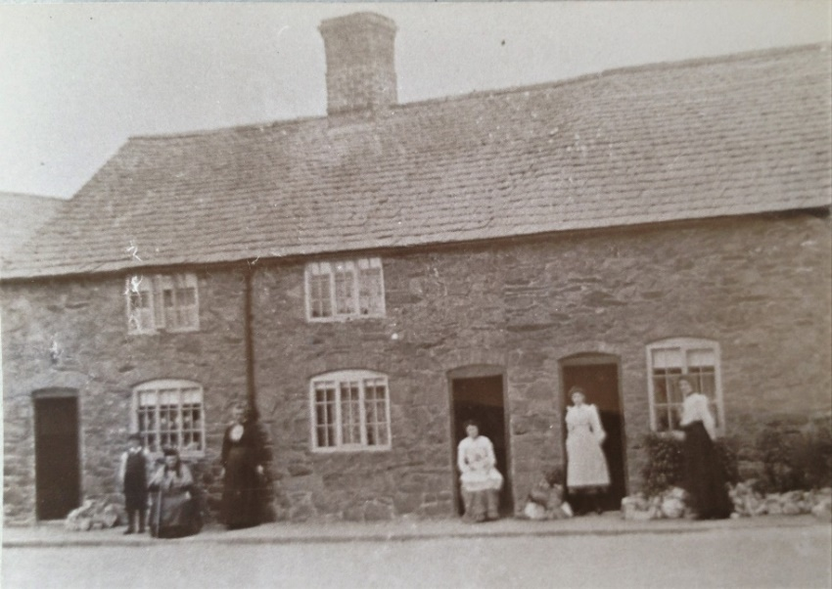 |  |  | 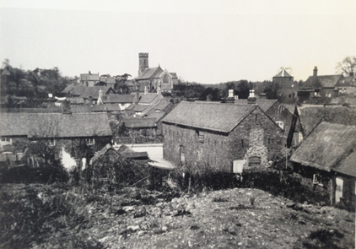

  - 18, 18A & 18B Ratby Road
18, 18A & 18B Ratby Road
Address | 18, 18A, & 18B, Ratby Road, LE6 0GG | 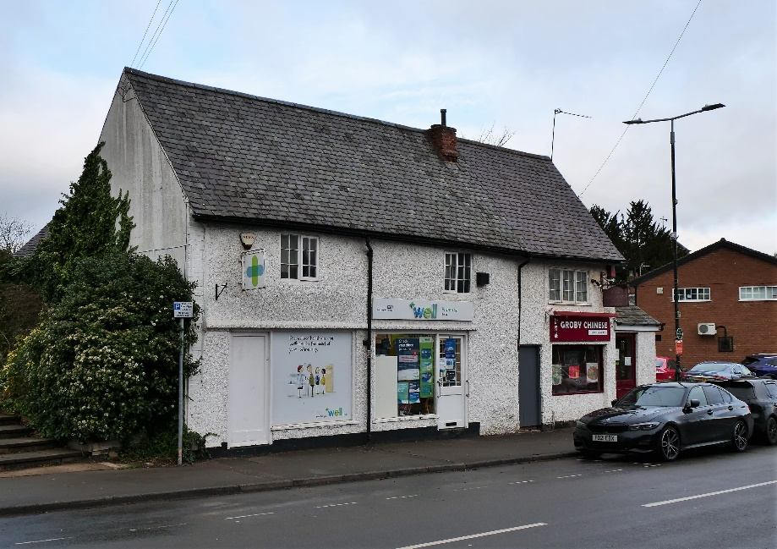
Grid Ref. | 452361, 307484
Asset Type | Building
Age | Unknown
Conservation Area | Yes
Selection Criteria
Value: Historic, Aesthetic-Architectural Interest
Significance: Group Value (Other historic buildings nearby, 1925 sale)
Description
Formally cruck-built cottages – timber framing hidden by protective brickwork. The properties have slate roofs.
Reason for Inclusion
Contributes to the village centre street scene in the conservation area.
Sources
- Identified as an unlisted building of local historic or architectural importance in HBBC Conservation Area Appraisal 2010.
- Appears in ‘A Guided Tour’ by Groby Village Society.
- Lot 130 in 1925 sale.
- Nominated by respondents (1) to the community survey March 2022 as a building of local historic and aesthetic importance.
- There is a building at this location on the following OS maps:
  - OS Six Inch 1885 (Surveyed 1885) Leicestershire Sheet XXX. N.E.
  - OS Six Inch 1904 (Surveyed 1901) Leicestershire Sheet XXX. N.E.
  - OS Six Inch 1919 (Surveyed 1914) Leicestershire Sheet XXX. N.E.
  - OS Six Inch 1930 (Surveyed 1928) Leicestershire Sheet XXX. N.E.
Notes
- Photographed by Andy Lincoln January 2022.

  - Former Groby Co-operative
Former Groby Co-operative
Address | Cathy Stephens Jewellery Ltd, 19-21, Ratby Road, LE6 0GF | 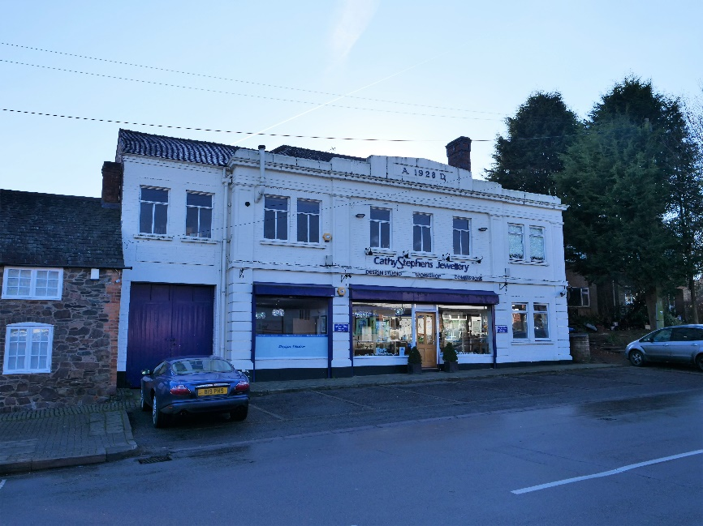
Grid Ref. | 452378, 307466
Asset Type | Building
Age | 1928
Conservation Area | Yes
Selection Criteria
Value: Historic, Aesthetic-Architectural Interest
Significance: Rarity – this is the only building of its kind in Groby, Landmark Quality
Description
A large, impressive building with a slate roof.
Groby Co-operative Society Store was at one time independent and run by local customers when it stood at the corner of Ratby Road and Fir Tree Lane and had its own bakery. On amalgamation with the Leicester Co-op, it moved to the new premises on the south-east side of Ratby Road in 1928. When the Co-op moved to the other side of Ratby Road, the premises became a jewellery workshop and shop. There are now two Co-ops in Groby village, one on Leicester Road and the other on Laundon Way.
Reason for Inclusion
This is the only building of its kind in Groby.
Sources
- Identified as an unlisted building of local historic or architectural importance in HBBC Conservation Area Appraisal 2010.
- Appears in ‘A Guided Tour’ by Groby Village Society.
- GPC submitted in 2014 to HBBC Register of Local Heritage Assets.
- Nominated by respondents (8) to the community survey March 2022 as a building of local historic and representative importance.
- There is a building at this location on the following OS maps:
  - OS Six Inch 1930 (Surveyed 1928) Leicestershire Sheet XXX. N.E.
Notes
- Photographed by Andy Lincoln January 2022.

  - 27 Ratby Road
27 Ratby Road
Address | 27, Ratby Road, LE6 0GF | 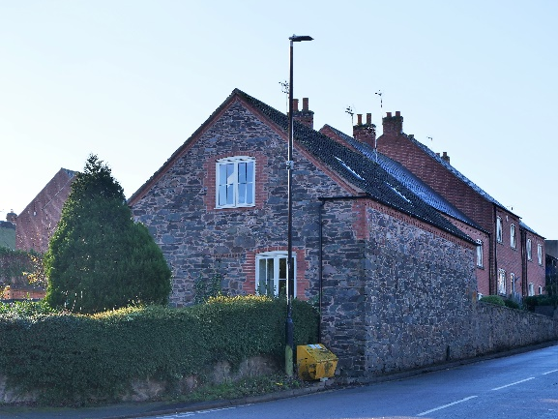
Grid Ref. | 452334, 307428
Asset Type | Building
Age | Unknown
Conservation Area | Yes
Selection Criteria
Value: Historic, Aesthetic-Architectural Interest
Significance: Group Value (Stone construction, 1925 sale)
Description
The stone outbuilding abutting the carriageway has been converted to a dwelling with a Groby slate roof.
Reason for Inclusion
Vernacular architecture.
Sources
- Identified as an unlisted building of local historic or architectural importance in HBBC Conservation Area Appraisal 2010.
- Nominated by AJC July 2021.
- Part of Lot 88 ‘Ivy House Farm’ in 1925 sale.
- There is a building at this location on the following OS maps:
  - OS Six Inch 1885 (Surveyed 1885) Leicestershire Sheet XXX. N.E.
  - OS Six Inch 1904 (Surveyed 1901) Leicestershire Sheet XXX. N.E.
  - OS Six Inch 1919 (Surveyed 1914) Leicestershire Sheet XXX. N.E.
  - OS Six Inch 1930 (Surveyed 1928) Leicestershire Sheet XXX. N.E.
Notes
- Photographed by Andy Lincoln January 2022.

  - Victoria Cottages
Victoria Cottages
Address | 132-158 Ratby Road, LE6 0BT |  | 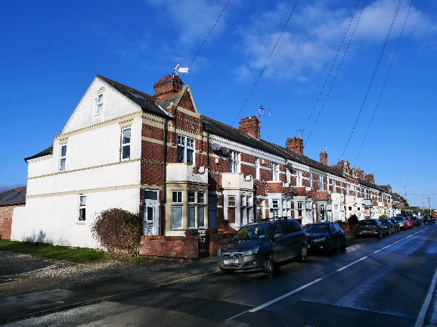
Grid Ref. | 452135, 307224
Asset Type | Building
Age | 1897
Conservation Area | No
Selection Criteria
Value: Historic, Aesthetic-Architectural Interest
Significance: Landmark Quality, Rarity – the only example of bay fronted Victorian villa terrace in Groby
Description
Row of bay fronted Victorian villas originally built with earth floors and now with mixed clay and slate roofs. Many have only recently been replaced with concrete infill.
Reason for Inclusion
This is the only example of a bay fronted Victorian villa terrace in Groby.
Sources
- Nominated by MAG December 2021.
- Nominated by David Ramsey 2022.
- Nominated by respondents (14) to the community survey March 2022 as a building of local historic, aesthetic, architectural, landmark, and group value importance.
- There is a building at this location on the following OS maps:
  - OS Six Inch 1904 (Surveyed 1901) Leicestershire Sheet XXX. N.E.
  - OS Six Inch 1919 (Surveyed 1914) Leicestershire Sheet XXX. N.E.
  - OS Six Inch 1930 (Surveyed 1928) Leicestershire Sheet XXX. N.E.
Notes
- Main photograph by Andy Lincoln January 2022.
Additional Photographs
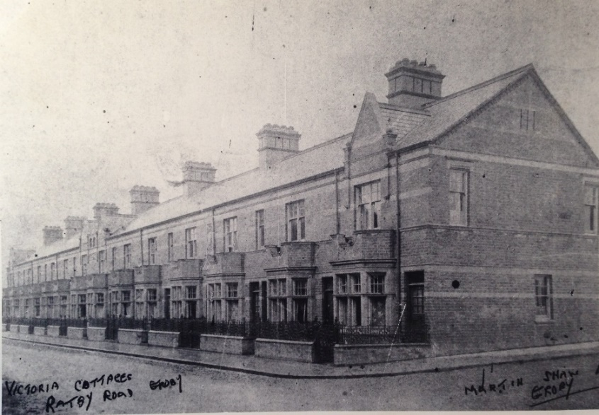 |  | 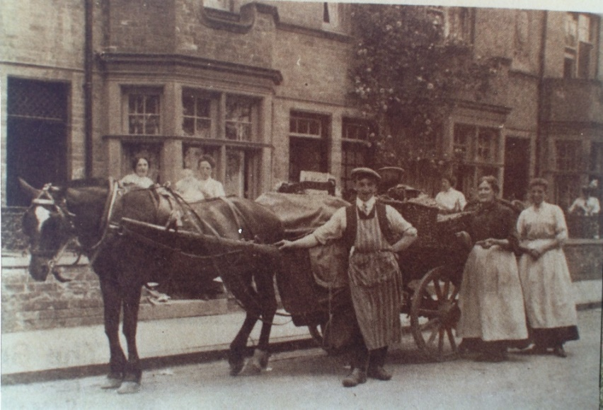 |  | 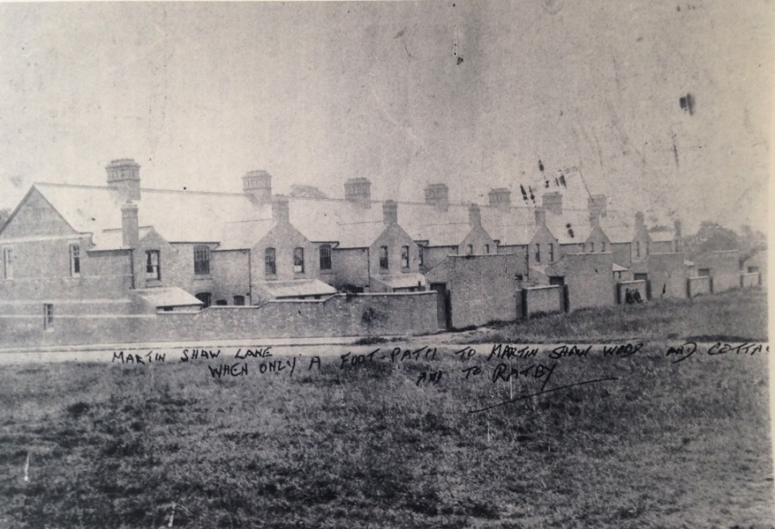

  - 79-117 Ratby Road
79-117 Ratby Road
Address | 79-117 Ratby Road, LE6 0GF |  | 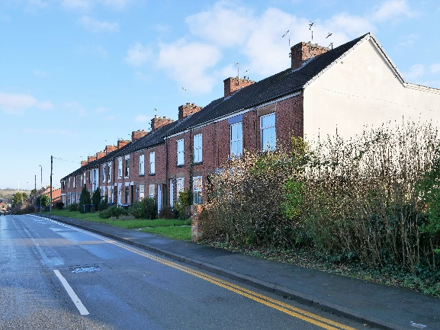
Grid Ref. | 452236, 307327
Asset Type | Building
Age | 1885-1893
Conservation Area | No
Selection Criteria
Value: Historic, Aesthetic-Architectural Interest
Significance: Landmark Quality, Group value (Quarrying)
Description
Brick terrace probably originally owned by Groby Granite and/or Victoria Patent Stone. Nos 79 and 81 were intended for Foremen and may have been of superior quality. Now with mixed clay and slate roofs.
Builder was Mr Hutchinson and the architect Mr Harding.
Reason for Inclusion
Architectural interest and the link with quarrying.
Sources
- Identified as an unlisted building of local historic or architectural importance in HBBC Conservation Area Appraisal 2010.
- Appears in ‘A Guided Tour’ by Groby Village Society.
- Nominated by AJC July 2021.
- Nominated by David Ramsey 2022.
- Nominated by respondents (7) to the community survey March 2022 as a building of local importance.
- There is a building at this location on the following OS maps:
  - OS Six Inch 1885 (Surveyed 1885) Leicestershire Sheet XXX. N.E. (only the southern half of the terrace)
  - OS Six Inch 1904 (Surveyed 1901) Leicestershire Sheet XXX. N.E.
  - OS Six Inch 1919 (Surveyed 1914) Leicestershire Sheet XXX. N.E.
  - OS Six Inch 1930 (Surveyed 1928) Leicestershire Sheet XXX. N.E.
Notes
- Main photograph by Andy Lincoln January 2022.
Additional Photographs
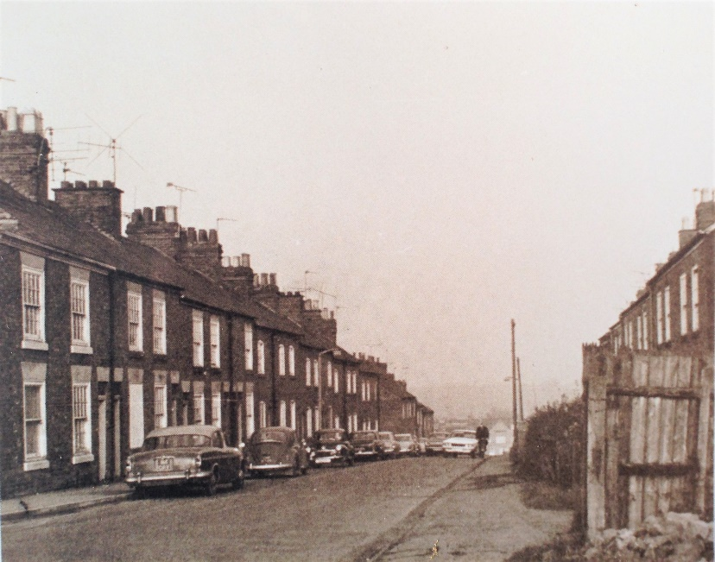

  - 118-124 Ratby Road
118-124 Ratby Road
Address | 118-124 Ratby Road, LE6 0GH |  | 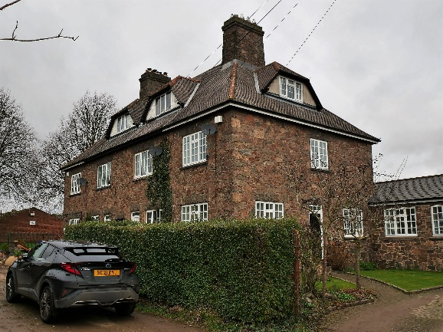
Grid Ref. | 452162, 307323
Asset Type | Building
Age | c. 1898
Conservation Area | No
Selection Criteria
Value: Historic, Aesthetic-Architectural Interest
Significance: Landmark Quality, Group value (Quarrying, 1925 sale)
Description
Block of four three-storey stone cottages with slate roof.
Reason for Inclusion
Imposing, vernacular architecture and link with quarrying.
Sources
- GPC submitted in 2014 to HBBC Register of Local Heritage Assets (although incorrectly identified as ‘Victoria Cottages’).
- Nominated by AJC July 2021.
- Nominated by David Ramsey 2022.
- David Ramsey suggested c. 1898 as rentals for Groby Granite Company.
- Part of Lot 95 of 1925 sale.
- Nominated by respondents (1) to the community survey March 2022 as a building of local importance.
- There is a building at this location on the following OS maps:
  - OS Six Inch 1904 (Surveyed 1901) Leicestershire Sheet XXX. N.E.
  - OS Six Inch 1919 (Surveyed 1914) Leicestershire Sheet XXX. N.E.
  - OS Six Inch 1930 (Surveyed 1928) Leicestershire Sheet XXX. N.E.
Notes
- Main photograph by Andy Lincoln January 2022.
Additional Photographs
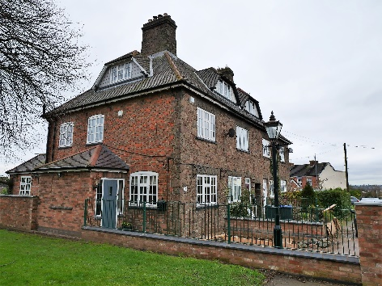 |  | 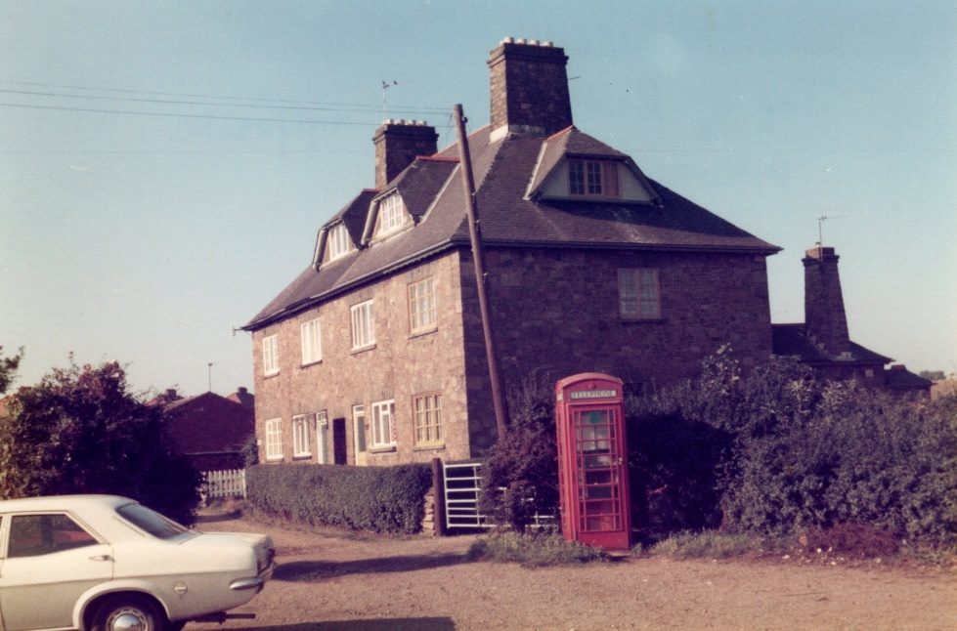

  - Quarry Manager’s House
Quarry Manager’s House
Address | The Hollies, 166 Ratby Road, LE6 0BT | 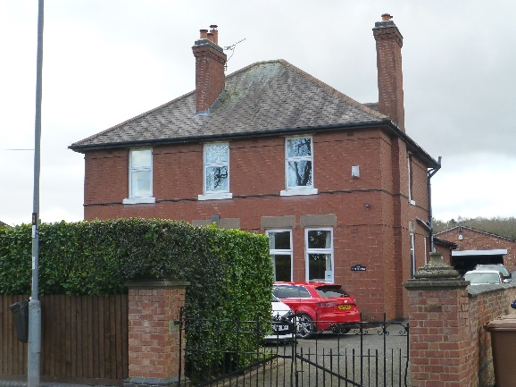
Grid Ref. | 452099, 307147
Asset Type | Building
Age | 1907
Conservation Area | No
Selection Criteria
Value: Historic, Aesthetic-Architectural Interest
Significance: Group Value (Quarrying)
Description
Large two-storey brick built house with slate roof. Built in 1907 and acquired in 1949 by Groby Granite Company.
Reason for Inclusion
Quarry Manager’s House.
Sources
- Nominated by David Ramsey 2022.
- Nominated by respondents (1) to the community survey March 2022 as a building of local historic, aesthetic, architectural, and group value importance.
- There is a building at this location on the following OS maps:
  - OS Six Inch 1919 (Surveyed 1914) Leicestershire Sheet XXX. N.E.
  - OS Six Inch 1930 (Surveyed 1928) Leicestershire Sheet XXX. N.E.
Notes
- Main photograph by Mark Griffin January 2022.

- Leicester Road
  - Chaplins Butchers Shop
Butchers Shop
Address | E, Chaplin & Sons (Butchers), 1, Leicester Road, LE6 0DQ |  | 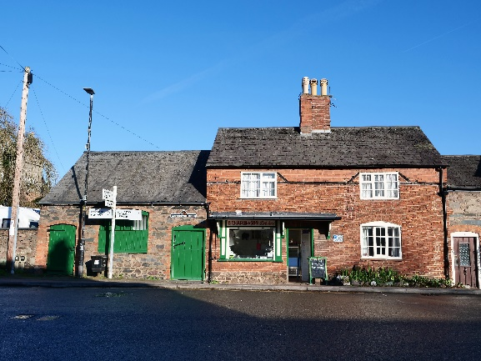
Grid Ref. | 452428, 307546
Asset Type | Building
Age | Elizabethan (1558-1603)
Conservation Area | Yes
Selection Criteria
Value: Historic, Aesthetic-Architectural Interest
Significance: Landmark Quality, Group Value (Construction, other historic buildings nearby, 1925 sale)
Description
This attractive property was once thatched but now has a Groby slate roof. The oldest part of the property dates from the Elizabethan era and more recent additions are from the 1800s. The building on the left was a slaughterhouse built c. 1925. The butchers ceased to trade in May 2022.
Reason for Inclusion
This attractive butchers shop and outbuildings situated at the junction of Ratby Road, Markfield Road and Leicester Road provide an excellent visual stop when approaching from Ratby Road.
William Chaplin was shot and badly wounded by poachers in 1825 and was slow to mend. He was assisted by the Earl of Stamford to sell game and other meats to ensure a livelihood whilst recovering.
Sources
- Identified as an unlisted building of local historic or architectural importance in HBBC Conservation Area Appraisal 2010.
- Appears in ‘A Guided Tour’ by Groby Village Society.
- GPC submitted in 2014 to HBBC Register of Local Heritage Assets.
- Nominated by David Ramsey 2022.
- Part of Lot 116 in 1925 sale.
- Nominated by respondents (50) to the community survey March 2022 as a building of local historic, community, and landmark importance.
- There is a building at this location on the following OS maps:
  - OS Six Inch 1885 (Surveyed 1885) Leicestershire Sheet XXX. N.E.
  - OS Six Inch 1904 (Surveyed 1901) Leicestershire Sheet XXX. N.E.
  - OS Six Inch 1919 (Surveyed 1914) Leicestershire Sheet XXX. N.E.
  - OS Six Inch 1930 (Surveyed 1928) Leicestershire Sheet XXX. N.E.
Notes
- Photographed by Andy Lincoln January 2022.
Additional Photographs
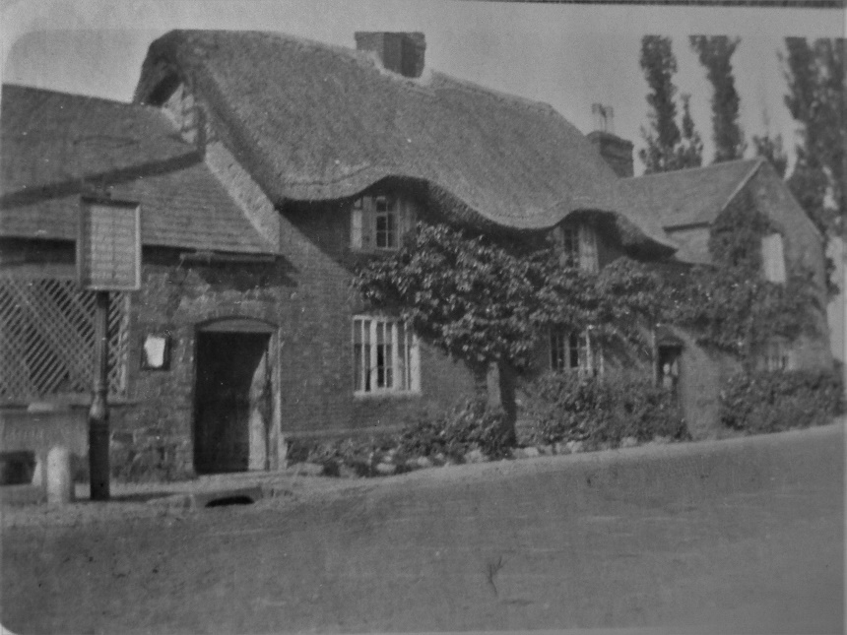 |  | 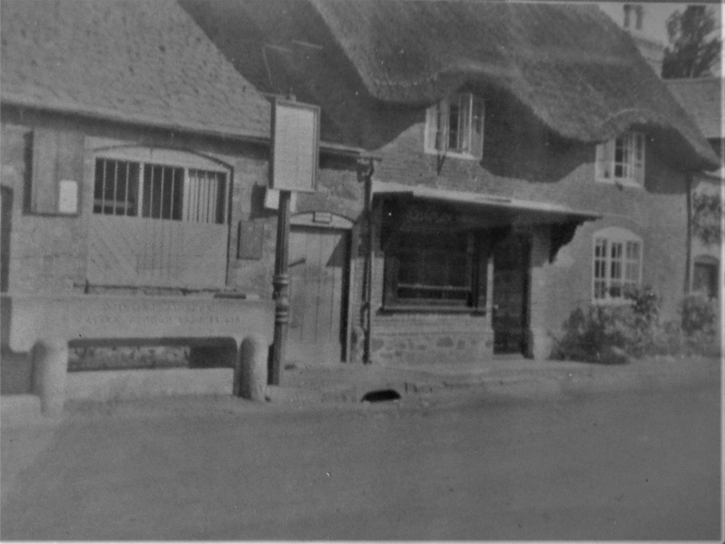 |  | 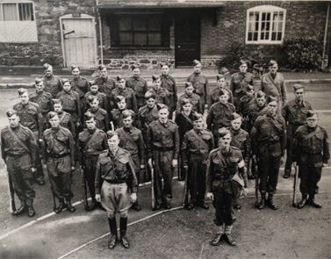
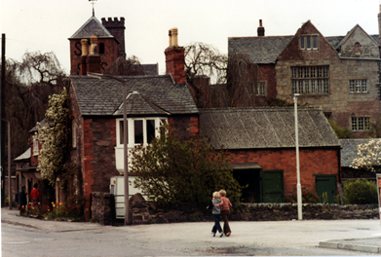

  - Cattle trough Leicester Road
Cattle trough Leicester Road
Address | LE6 0DQ | 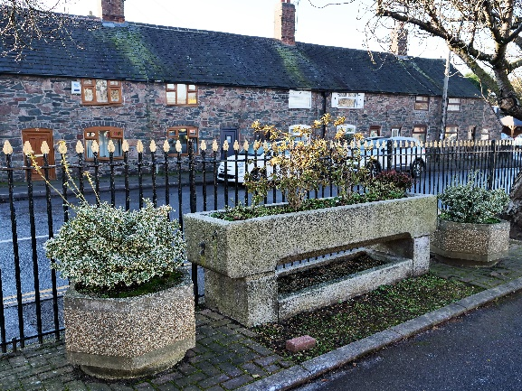
Grid Ref. | 452573, 307488
Asset Type | Cattle trough
Age | 1909
Conservation Area | Yes
Selection Criteria
Value: Historic
Significance: Rarity
Description
This cattle trough was ‘opened’ in late summer of 1909 and on the front was inscribed ‘Drinking Fountain & Cattle Trough Association, 70 Victoria St, S.W.’ The trough was later placed in front of the village hall car park.
Reason for Inclusion
Unusual feature.
Sources
- Identified on the HBBC Conservation Area Appraisal 2010 Photographic Survey.
- Details from groby.org.uk.
Notes
- Main photograph by Andy Lincoln January 2022.
Additional Photographs
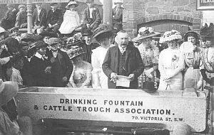 |  |  | 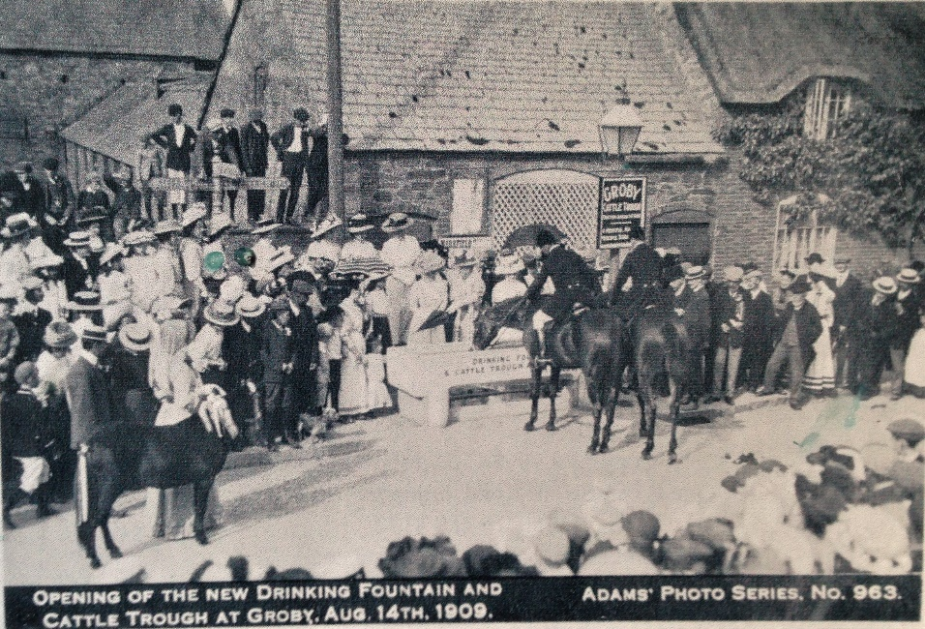

  - Village Hall
Village Hall
Address | Groby Village Hall, Leicester Road, LE6 0DQ | 
Grid Ref. | 452585, 307510
Asset Type | Building
Age | 1907
Conservation Area | Yes
Selection Criteria
Value: Historic, Aesthetic-Architectural Interest
Significance: Landmark Quality, Group Value (Stone construction, other former school buildings nearby)
Description
The Village Hall is the former Village Junior School built in 1907 in stone with ashlar dressings and slate roof. The school opened with Headmaster Mr. Waldron and three teachers catering for 137 children in four classes. In the 1960s, when is became too small for the growing numbers of quarrymen’s children, it was replaced by the first of the modern schools. It was then sold to the village for a nominal sum.
Reason for Inclusion
Vernacular architecture.
Sources
- Identified as an unlisted building of local historic or architectural importance in HBBC Conservation Area Appraisal 2010.
- Appears in ‘A Guided Tour’ by Groby Village Society.
- GPC submitted in 2014 to HBBC Register of Local Heritage Assets.
- Identified by respondents (20) to the community survey March 2022 as a building of local historic and aesthetic importance.
- There is a building at this location on the following OS maps:
  - OS Six Inch 1919 (Surveyed 1914) Leicestershire Sheet XXX. N.E.
  - OS Six Inch 1930 (Surveyed 1928) Leicestershire Sheet XXX. N.E.
Notes
- Photographed by Andy Lincoln January 2022.

  - The Old Schoolmasters House
The Old Schoolmasters House
Address | 57, Leicester Road, LE6 0DQ | 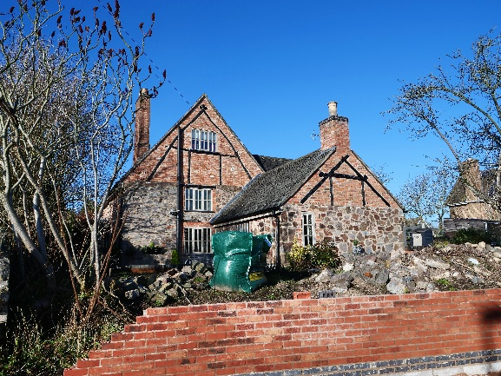
Grid Ref. | 452642, 307463
Asset Type | Building
Age | Unknown
Conservation Area | Yes
Selection Criteria
Value: Historic, Aesthetic-Architectural Interest
Significance: Group Value (Stone construction, other former school buildings nearby)
Description
Originally owned by the Earl of Stamford it was the home of Schoolmaster Mr. Waldron, and later his daughter. The original thatched roof was replaced with Groby slate. The building is thought to have been a Toll House at one time.
Reason for Inclusion
Vernacular architecture
Sources
- Identified as an unlisted building of local historic or architectural importance in HBBC Conservation Area Appraisal 2010.
- Appears in ‘A Guided Tour’ by Groby Village Society.
- Recorded in the Leicestershire and Rutland HER (MLE16257).
- Identified by respondents (1) to the community survey March 2022 as a building of local importance.
- There is a building at this location on the following OS maps:
  - OS Six Inch 1885 (Surveyed 1885) Leicestershire Sheet XXX. N.E.
  - OS Six Inch 1904 (Surveyed 1901) Leicestershire Sheet XXX. N.E.
  - OS Six Inch 1919 (Surveyed 1914) Leicestershire Sheet XXX. N.E.
  - OS Six Inch 1930 (Surveyed 1928) Leicestershire Sheet XXX. N.E.
Notes
- Photographed by Andy Lincoln January 2022.

  - War Memorial at Groby Club
War Memorial at Groby Club
Address | 16-18 Leicester Road, LE6 0DJ | 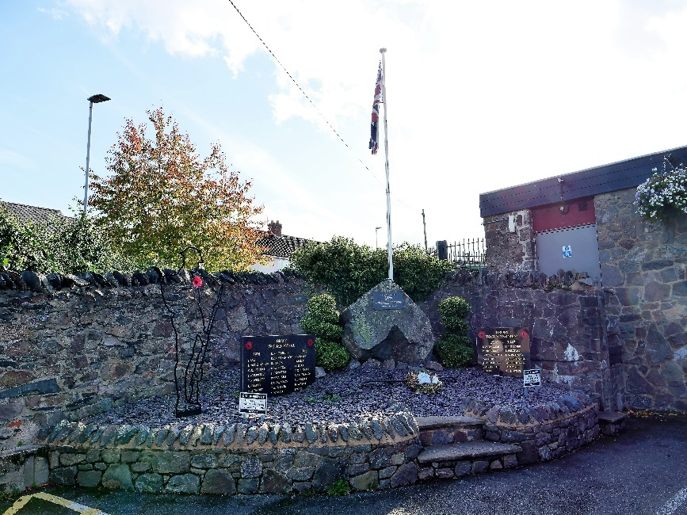
Grid Ref. | 452500, 307477
Asset Type | Monument
Age | c. 2012
Conservation Area | Yes
Selection Criteria
Value: Historic
Significance:
Description
Large granite Stone of Remembrance set within a low-walled, hard landscaped corner of club car park. Incised slate tablet incorporating a Union flag design, attached to front face of stone. Inscription lettering infilled in a gold colour & flag infilled red, white & blue. Flagpole to the rear of stone.
Reason for Inclusion
Poignant reminder of the multi-generational contribution that Groby residents made to the two world wars.
Sources
- Nominated by Historical Environment Working Group 2022
Notes
- Photographed by Andy Lincoln October 2022.
Additional Photographs

  - 20-30 Leicester Road
20-30 Leicester Road
Address | 20-30 Leicester Road, LE6 0DJ | 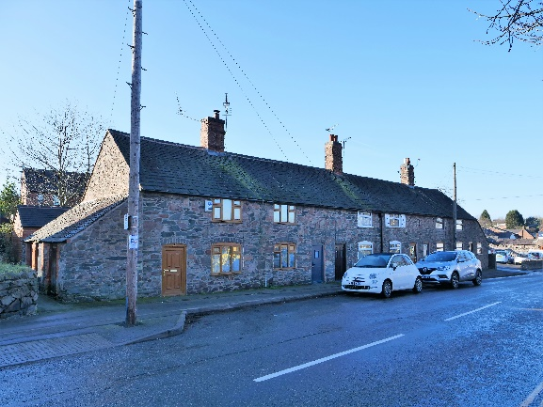
Grid Ref. | 452553, 307480
Asset Type | Building
Age | Unknown
Conservation Area | Yes
Selection Criteria
Value: Historic, Aesthetic-Architectural Interest
Significance: Landmark Quality, Group Value (Stone construction, other historic buildings nearby, 1925 sale)
Description
The doorways on these houses suggest circa 1500 when they would have been single storey and probably thatched. The properties have Groby slate roofs.
Reason for Inclusion
Vernacular architecture.
Sources
- Identified as an unlisted building of local historic or architectural importance in HBBC Conservation Area Appraisal 2010.
- GPC submitted in 2014 to HBBC Register of Local Heritage Assets (as ‘Stone Row Cottages Opposite Village Hall).
- Nominated by David Ramsey 2022.
- Lot 119 in 1925 sale.
- Nominated by respondents (10) to the community survey March 2022 as a building of local historic importance.
- There is a building at this location on the following OS maps:
  - OS Six Inch 1885 (Surveyed 1885) Leicestershire Sheet XXX. N.E.
  - OS Six Inch 1904 (Surveyed 1901) Leicestershire Sheet XXX. N.E.
  - OS Six Inch 1919 (Surveyed 1914) Leicestershire Sheet XXX. N.E.
  - OS Six Inch 1930 (Surveyed 1928) Leicestershire Sheet XXX. N.E.
Notes
- Photographed by Andy Lincoln January 2022.

  - Victoria Stone Terrace, 32-42 Leicester Road
Victoria Stone Terrace, 32-42 Leicester Road
Address | 32-42 Leicester Road, LE6 0DJ | 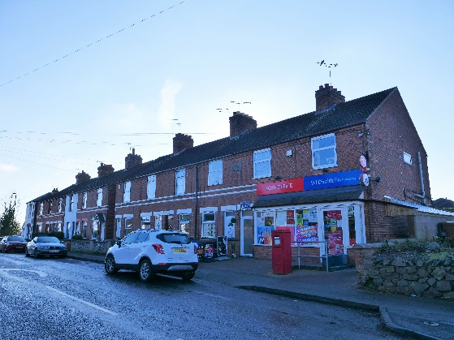
Grid Ref. | 452579, 307464
Asset Type | Building
Age | Pre 1885
Conservation Area | Yes
Selection Criteria
Value: Historic, Aesthetic-Architectural Interest
Significance: Group value (Quarrying)
Description
Brick built terrace with clay roofs.
Reason for Inclusion
Presumably originally built by the Victoria Stone Company operating at Sheet Hedges Quarry.
Sources
- Identified as an unlisted building of local historic or architectural importance in HBBC Conservation Area Appraisal 2010.
- Nominated by AJC July 2021.
- Nominated by respondents (3) to the community survey March 2022 as a building of local historic importance.
- There is a building at this location on the following OS maps:
  - OS Six Inch 1885 (Surveyed 1885) Leicestershire Sheet XXX. N.E.
  - OS Six Inch 1904 (Surveyed 1901) Leicestershire Sheet XXX. N.E.
  - OS Six Inch 1919 (Surveyed 1914) Leicestershire Sheet XXX. N.E.
  - OS Six Inch 1930 (Surveyed 1928) Leicestershire Sheet XXX. N.E.
Notes
- Photographed by Andy Lincoln January 2022.

  - Victoria Stone Terrace, 44-54 Leicester Road
Victoria Stone Terrace, 32-42 Leicester Road
Address | 44-54 Leicester Road, LE6 0DJ | 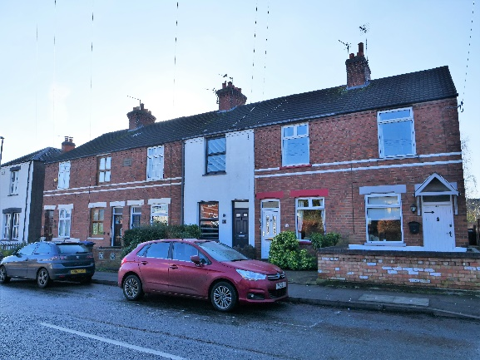
Grid Ref. | 452602, 307452
Asset Type | Building
Age | Pre 1885
Conservation Area | Yes
Selection Criteria
Value: Historic, Aesthetic-Architectural Interest
Significance: Group Value (Quarrying)
Description
Brick built terrace with clay roofs.
Reason for Inclusion
In 1891 sold by John Griffiths to the Victoria Patent Stone Company Ltd (operating at Sheet Hedges Quarry).
Sources
- Identified as an unlisted building of local historic or architectural importance in HBBC Conservation Area Appraisal 2010.
- Nominated by David Ramsey 2022.
- Nominated by respondents (1) to the community survey March 2022 as a building of local historic importance.
- There is a building at this location on the following OS maps:
  - OS Six Inch 1885 (Surveyed 1885) Leicestershire Sheet XXX. N.E.
  - OS Six Inch 1904 (Surveyed 1901) Leicestershire Sheet XXX. N.E.
  - OS Six Inch 1919 (Surveyed 1914) Leicestershire Sheet XXX. N.E.
  - OS Six Inch 1930 (Surveyed 1928) Leicestershire Sheet XXX. N.E.
Notes
- Photographed by Andy Lincoln January 2022.

  - 56 Leicester Road
56 Leicester Road
Address | Flats 1-2, Mount Pleasant, 56, Leicester Road, LE6 0DJ | 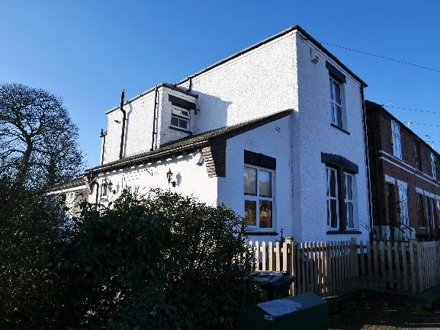
Grid Ref. | 452613, 307445
Asset Type | Building
Age | Pre 1885
Conservation Area | Yes
Selection Criteria
Value: Historic, Aesthetic-Architectural Interest
Significance:
Description
A large, rendered property with slate roof converted into two flats.
Reason for Inclusion
The building commands a prominent position at the top of Leicester Road.
Sources
- Identified as an unlisted building of local historic or architectural importance in HBBC Conservation Area Appraisal 2010.
- There is a building at this location on the following OS maps:
  - OS Six Inch 1885 (Surveyed 1885) Leicestershire Sheet XXX. N.E.
  - OS Six Inch 1904 (Surveyed 1901) Leicestershire Sheet XXX. N.E.
  - OS Six Inch 1919 (Surveyed 1914) Leicestershire Sheet XXX. N.E.
  - OS Six Inch 1930 (Surveyed 1928) Leicestershire Sheet XXX. N.E.
Notes
- Photographed by Andy Lincoln January 2022.

  - 65 Leicester Road
65 Leicester Road
Address | 65, Leicester Road, LE6 0DJ | 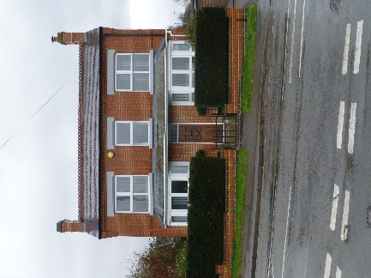
Grid Ref. | 452673, 307458
Asset Type | Building
Age | 1901-1914
Conservation Area | No
Selection Criteria
Value: Historic, Aesthetic-Architectural Interest
Significance: Landmark Quality
Description
Impressive frontage, significantly extended to rear. Brick built with slate roof.
Reason for Inclusion
Edwardian house rare to Groby in a commanding location
Sources
- Nominated by MAG March 2022.
- There is a building at this location on the following OS maps:
  - OS Six Inch 1919 (Surveyed 1914) Leicestershire Sheet XXX. N.E.
  - OS Six Inch 1930 (Surveyed 1928) Leicestershire Sheet XXX. N.E.
Notes
- Photographed by Mark Griffin February 2022.
- Chapel Hill
  - 21 Chapel Hill
21 Chapel Hill
Address | 21, Chapel Hill, LE6 0FE | 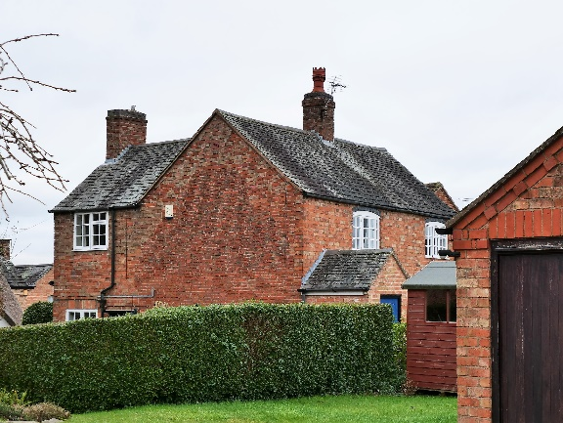
Grid Ref. | 452352, 307345
Asset Type | Building
Age | c. 1750
Conservation Area | Yes
Selection Criteria
Value: Historic, Aesthetic-Architectural Interest
Significance: Group Value (Chapel Hill, 1925 sale)
Description
The property has a Groby slate roof.
Reason for Inclusion
Forms part of the attractive Chapel Hill cluster of historic buildings in Groby
Sources
- Identified as an unlisted building of local historic or architectural importance in HBBC Conservation Area Appraisal 2010.
- Lot 134 in 1925 sale.
- Nominated by respondents (15) to the community survey March 2022 as a building of local historic importance.
- There is a building at this location on the following OS maps:
  - OS Six Inch 1885 (Surveyed 1885) Leicestershire Sheet XXX. N.E.
  - OS Six Inch 1904 (Surveyed 1901) Leicestershire Sheet XXX. N.E.
  - OS Six Inch 1919 (Surveyed 1914) Leicestershire Sheet XXX. N.E.
  - OS Six Inch 1930 (Surveyed 1928) Leicestershire Sheet XXX. N.E.
Notes
- Photographed by Andy Lincoln January 2022.

  - 29 Chapel Hill
29 Chapel Hill
Address | 29, Chapel Hill, LE6 0FE | 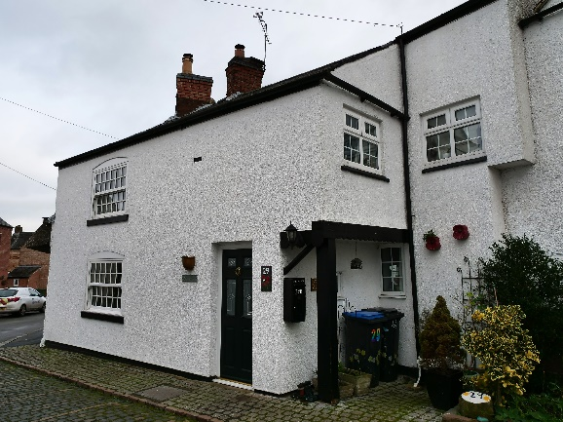
Grid Ref. | 452323, 307344
Asset Type | Building
Age | Unknown
Conservation Area | Yes
Selection Criteria
Value: Historic, Aesthetic-Architectural Interest
Significance: Group Value (Chapel Hill)
Description
The property has a slate roof.
Reason for Inclusion
Forms part of the attractive Chapel Hill cluster of historic buildings in Groby
Sources
- Identified as an Important Historical Building in HBBC Conservation Area Appraisal 2010.
- Nominated by respondents (15) to the community survey March 2022 as a building of local historic importance.
- There is a building at this location on the following OS maps:
  - OS Six Inch 1885 (Surveyed 1885) Leicestershire Sheet XXX. N.E.
  - OS Six Inch 1904 (Surveyed 1901) Leicestershire Sheet XXX. N.E.
  - OS Six Inch 1919 (Surveyed 1914) Leicestershire Sheet XXX. N.E.
  - OS Six Inch 1930 (Surveyed 1928) Leicestershire Sheet XXX. N.E.
Notes
- Photographed by Andy Lincoln January 2022.

  - 30 Chapel Hill
30 Chapel Hill
Address | 30, Chapel Hill, LE6 0FE | 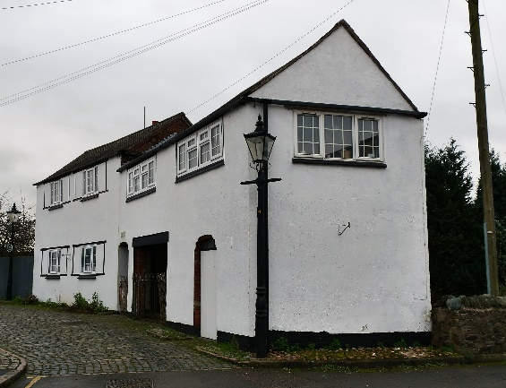
Grid Ref. | 452312, 307342
Asset Type | Building
Age | Circa 1750
Conservation Area | Yes
Selection Criteria
Value: Historic, Aesthetic-Architectural Interest
Significance: Group Value (Chapel Hill), Rarity
Description
This former Framesmith’s cottage and workshop has large rectangular window openings, several of which have now been reduced in size. This building represents the only surviving example of an early industrial building in the village. The property has a slate roof.
Both units have had the roof raised using the cheapest timbers available.
Reason for Inclusion
Forms part of the attractive Chapel Hill cluster of historic buildings in Groby
Sources
- Identified as an unlisted building of local historic or architectural importance in HBBC Conservation Area Appraisal 2010.
- Appears in ‘A Guided Tour’ by Groby Village Society.
- Nominated by David Ramsey 2022.
- Nominated by respondents (15) to the community survey March 2022 as a building of local historic importance.
- There is a building at this location on the following OS maps:
  - OS Six Inch 1885 (Surveyed 1885) Leicestershire Sheet XXX. N.E.
  - OS Six Inch 1904 (Surveyed 1901) Leicestershire Sheet XXX. N.E.
  - OS Six Inch 1919 (Surveyed 1914) Leicestershire Sheet XXX. N.E.
  - OS Six Inch 1930 (Surveyed 1928) Leicestershire Sheet XXX. N.E.
Notes
- Photographed by Andy Lincoln January 2022.

  - 31 Chapel Hill
31 Chapel Hill
Address | 31, Chapel Hill, LE6 0FE | 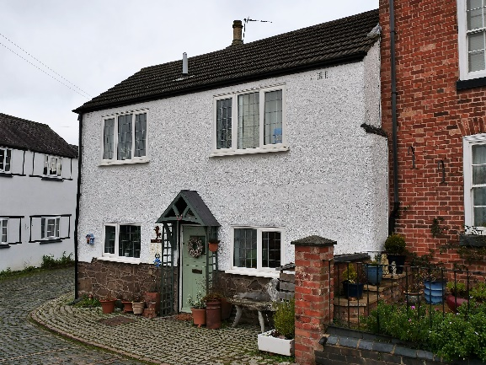
Grid Ref. | 452323, 307336
Asset Type | Building
Age | Unknown
Conservation Area | Yes
Selection Criteria
Value: Historic, Aesthetic-Architectural Interest
Significance: Group Value (Chapel Hill)
Description
31 Chapel Hill was once a Grade II listed property built in red brick with slate roof with south side faced jetted out with rough cast first floor. However, the dwelling was de-listed due to its modernisation with concrete roof tiles and plastic windows.
Reason for Inclusion
The three properties 31-35 Chapel Hill (No. 33 is listed) are attractive as a group.
Sources
- Identified as an unlisted building of local historic or architectural importance in HBBC Conservation Area Appraisal 2010.
- Nominated by respondents (15) to the community survey March 2022 as a building of local historic importance.
- There is a building at this location on the following OS maps:
  - OS Six Inch 1885 (Surveyed 1885) Leicestershire Sheet XXX. N.E.
  - OS Six Inch 1904 (Surveyed 1901) Leicestershire Sheet XXX. N.E.
  - OS Six Inch 1919 (Surveyed 1914) Leicestershire Sheet XXX. N.E.
  - OS Six Inch 1930 (Surveyed 1928) Leicestershire Sheet XXX. N.E.
Notes
- Photographed by Andy Lincoln January 2022.

  - 35 Chapel Hill
35 Chapel Hill
Address | April Cottage, 35, Chapel Hill, LE6 0FE | 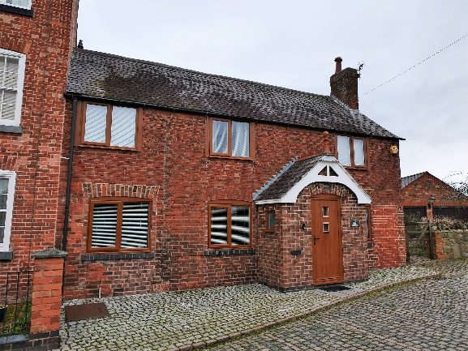
Grid Ref. | 452337, 307329
Asset Type | Building
Age | Unknown
Conservation Area | Yes
Selection Criteria
Value: Historic, Aesthetic-Architectural Interest
Significance: Group Value (Chapel Hill)
Description
This building has an early C19 façade which is rough cast with an angled side adjoining No. 29. The rear is probably earlier than the front façade. It has a modern pantile roof. It has 2 storeys with 2 windows early C19 casements with glazing bard and cambered head linings to ground floor. It has modern casements in C19 window openings above. It has a centre door with a small flat canopy on slatted brackets. The side façade has one window on each floor.
Part of which was once an off license.
Reason for Inclusion
The three properties 31-35 Chapel Hill (No. 33 is listed) are attractive as a group.
Sources
- Identified as an Important Historical Building in HBBC Conservation Area Appraisal 2010.
- Nominated by respondents (15) to the community survey March 2022 as a building of local historic importance.
- There is a building at this location on the following OS maps:
  - OS Six Inch 1885 (Surveyed 1885) Leicestershire Sheet XXX. N.E.
  - OS Six Inch 1904 (Surveyed 1901) Leicestershire Sheet XXX. N.E.
  - OS Six Inch 1919 (Surveyed 1914) Leicestershire Sheet XXX. N.E.
  - OS Six Inch 1930 (Surveyed 1928) Leicestershire Sheet XXX. N.E.
Notes
- Photographed by Andy Lincoln January 2022.

  - Footpath linking Chapel Hill to Ferrers Rise
Footpath linking Chapel Hill to Ferrers Rise
Address | Between Chapel Hill and Ferrers Rise, LE6 0FE | 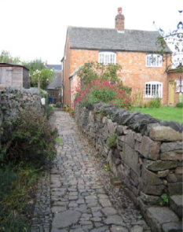
Grid Ref. | 452353, 307339
Asset Type | Footpath
Age | Unknown
Conservation Area | Yes
Selection Criteria
Value: Historic, Aesthetic-Architectural Interest
Significance: Group Value (Chapel Hill)
Description
Picturesque footpath surfaces and flanked with stone.
Reason for Inclusion
Forms part of the attractive Chapel Hill centre of historic buildings in Groby
Sources
- Mentioned in HBBC Conservation Area Appraisal 2010.
- There appears to be a thoroughfare at this location on the following OS maps:
  - OS Six Inch 1885 (Surveyed 1885) Leicestershire Sheet XXX. N.E.
  - OS Six Inch 1904 (Surveyed 1901) Leicestershire Sheet XXX. N.E.
- The following OS maps may show the thoroughfare as terminated in the middle:
  - OS Six Inch 1919 (Surveyed 1914) Leicestershire Sheet XXX. N.E.
  - OS Six Inch 1930 (Surveyed 1928) Leicestershire Sheet XXX. N.E.
Notes
- Photo from Conservation Area Appraisal 2010 – contemporary photo needed.
- Shown as a public footpath in HBBC Appraisal Map and misleadingly described as ‘linking Chapel Hill to Ferrers Rise – when questioned about the path being public, HBBC did not respond. It appears to be private.
- Steering Group Meeting 25/08/2022 – further investigation needed
Additional Photographs
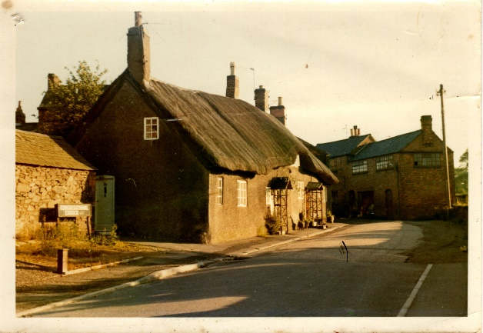
Shows footpath from Chapel Hill to Ferrers Rise.

- Markfield Road
  - 1-9 Markfield Road
1-9 Markfield Road
Address | 1-9 Markfield Road, LE6 0FL | 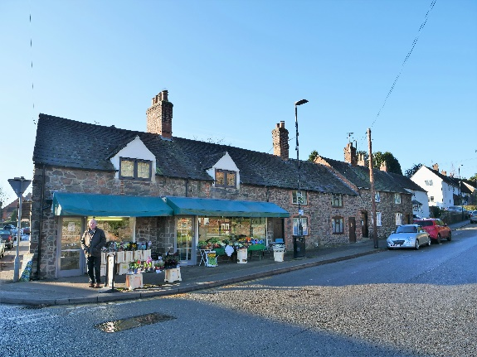
Grid Ref. | 452387, 307539
Asset Type | Building
Age | c. C17
Conservation Area | Yes
Selection Criteria
Value: Historic, Aesthetic-Architectural Interest
Significance: Group Value (Stone construction, other historic buildings nearby, 1925 sale)
Description
Stone terrace with slate roofs
Reason for Inclusion
1 Markfield Road sited at the junction with Ratby Road is a pleasant stone property with Groby slate roof. The chimney stacks and pots are imposing features in this part of the conservation area.
The terrace of four dwellings (3-9 Markfield Road) are stone properties with Groby slate roofs and dominant chimney stacks.
Sources
- Identified as an unlisted building of local historic or architectural importance in HBBC Conservation Area Appraisal 2010.
- Nominated by AJC July 2021.
- Nominated by David Ramsey 2022.
- Nominated by respondents (5) to the community survey March 2022 as a building of local historic importance.
- Lot 115 in 1925 sale.
- There is a building at this location on the following OS maps:
  - OS Six Inch 1885 (Surveyed 1885) Leicestershire Sheet XXX. N.E.
  - OS Six Inch 1904 (Surveyed 1901) Leicestershire Sheet XXX. N.E.
  - OS Six Inch 1919 (Surveyed 1914) Leicestershire Sheet XXX. N.E.
  - OS Six Inch 1930 (Surveyed 1928) Leicestershire Sheet XXX. N.E.
Notes
- Photographed by Andy Lincoln January 2022.
Additional Photographs
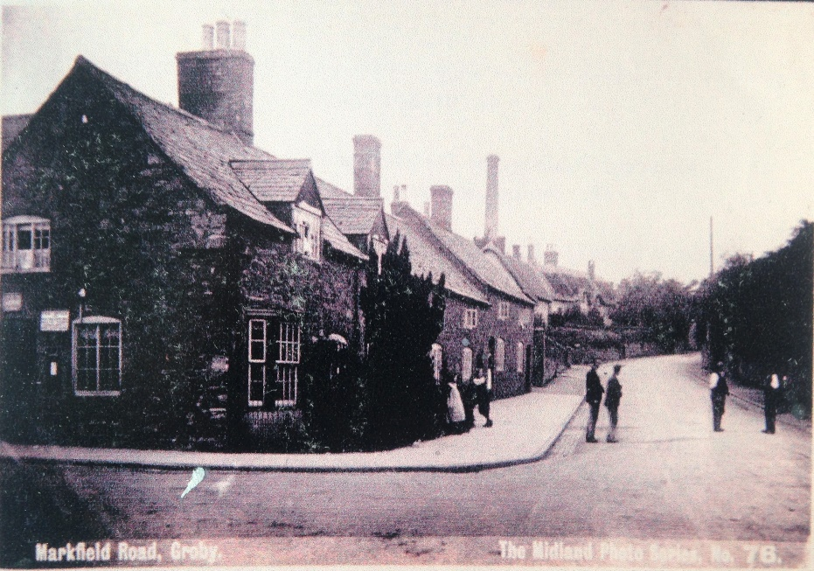 |  |  | 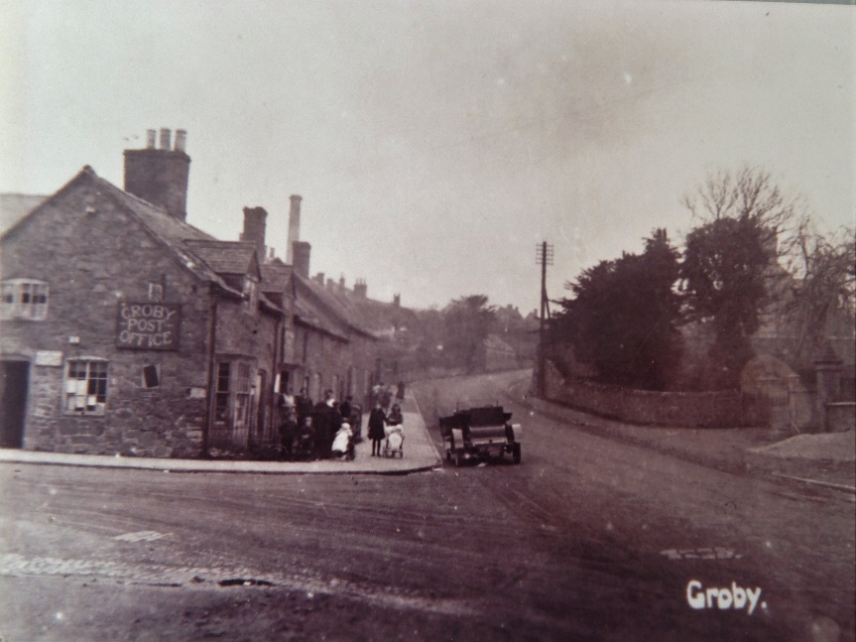
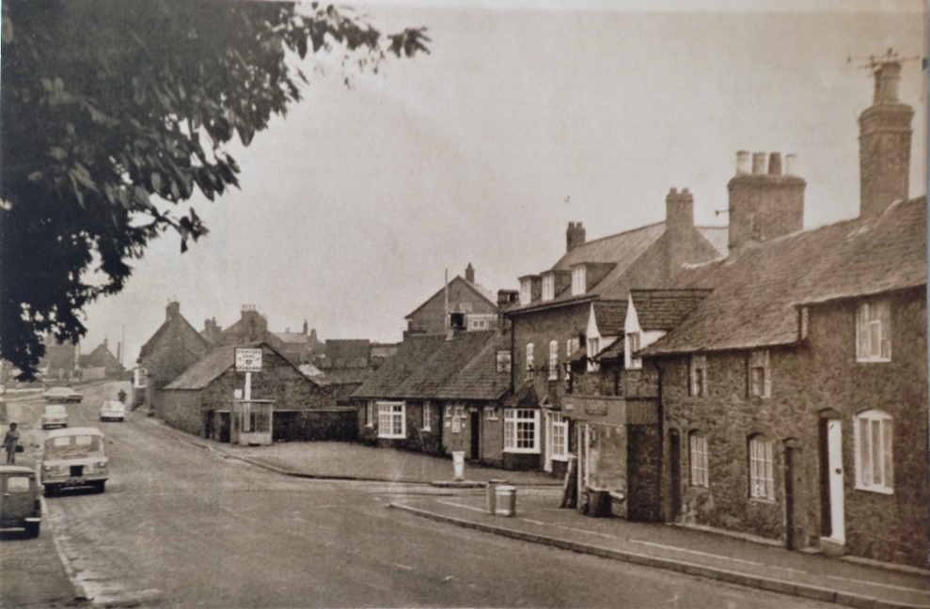

  - 11 Markfield Road
11 Markfield Road
Address | 11, Markfield Road, LE6 0FL | 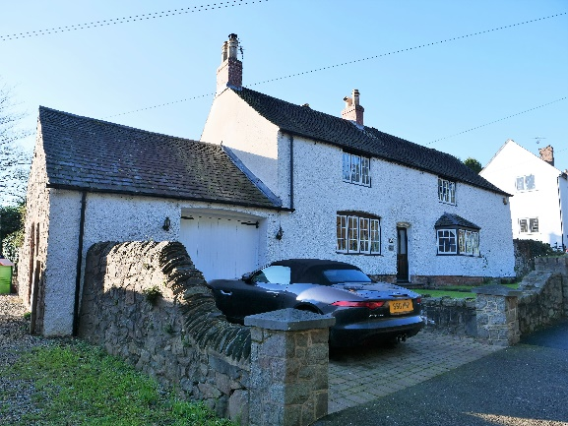
Grid Ref. | 452358, 307540
Asset Type | Building
Age | Unknown
Conservation Area | Yes
Selection Criteria
Value: Historic, Aesthetic-Architectural Interest
Significance: Group Value
Description
A large, rendered dwelling, painted white, with a stone plinth, Groby slate roof and stone boundary walls. The property still has chimney stacks and pots, and a front bay window has been added. The property was once a public house (the former Stamford Arms).
Reason for Inclusion
Forms part of the Markfield Road cluster of historic buildings in Groby
Sources
- Identified as an unlisted building of local historic or architectural importance in HBBC Conservation Area Appraisal 2010.
- Appeared in ‘A Guided Tour’ by Groby Village Society.
- Nominated by respondents (1) to the community survey March 2022 as a building of local historic importance.
- There is a building at this location on the following OS maps:
  - OS Six Inch 1885 (Surveyed 1885) Leicestershire Sheet XXX. N.E.
  - OS Six Inch 1904 (Surveyed 1901) Leicestershire Sheet XXX. N.E.
  - OS Six Inch 1919 (Surveyed 1914) Leicestershire Sheet XXX. N.E.
  - OS Six Inch 1930 (Surveyed 1928) Leicestershire Sheet XXX. N.E.
Notes
- Main photograph by Andy Lincoln January 2022.
Additional Photographs
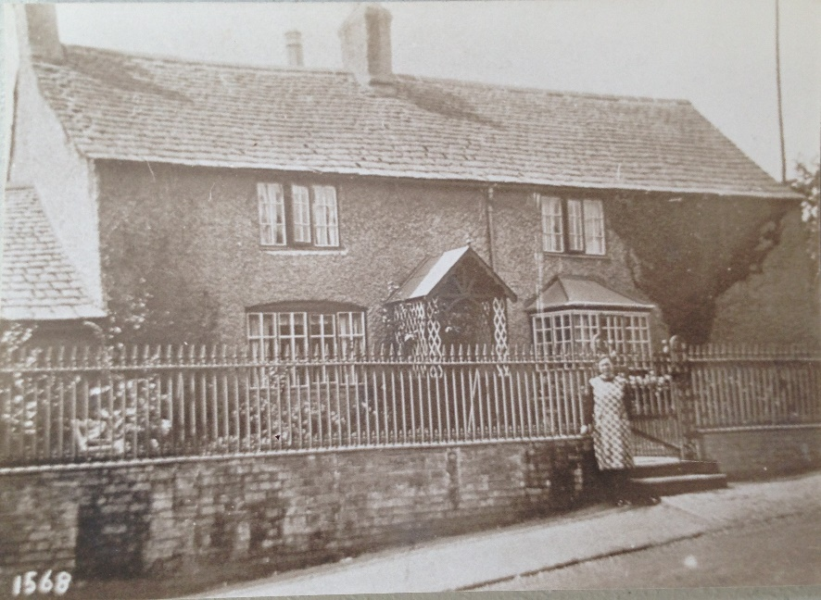

  - 13 Markfield Road
13 Markfield Road
Address | 13, Markfield Road, LE6 0FL |  | 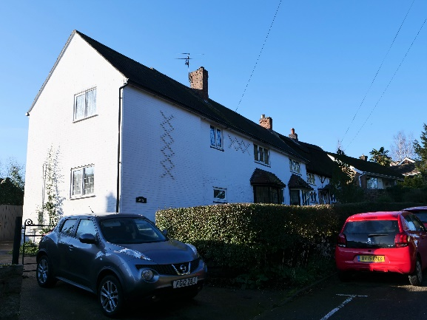
Grid Ref. | 452337, 307550
Asset Type | Building
Age | Stuart era (1603-1714)
Conservation Area | Yes
Selection Criteria
Value: Historic, Aesthetic-Architectural Interest
Significance: Group Value (1925 sale)
Description
This property was originally two thatched cottages and an upper floor was added to the left of the building in 1984. The property is now rendered, painted white and with a slate roof and interesting diaper brickwork. When the two cottages were joined, the wall that was knocked through was found to be constructed of wattle and daub and in the cavity was discovered a mummified cat, a shoe from the Stuart era (thought to ward off evil spirits and witches) and some coins (these articles may now be found in Leicester Museum). There is an existing, brick-lined well to the rear of the property.
Reason for Inclusion
Forms part of the Markfield Road cluster of historic buildings in Groby
Sources
- Identified as an unlisted building of local historic or architectural importance in HBBC Conservation Area Appraisal 2010.
- Nominated by respondents (1) to the community survey March 2022 as a building of local historic importance.
- Lot 114 in 1925 sale.
- There is a building at this location on the following OS maps:
  - OS Six Inch 1885 (Surveyed 1885) Leicestershire Sheet XXX. N.E.
  - OS Six Inch 1904 (Surveyed 1901) Leicestershire Sheet XXX. N.E.
  - OS Six Inch 1919 (Surveyed 1914) Leicestershire Sheet XXX. N.E.
  - OS Six Inch 1930 (Surveyed 1928) Leicestershire Sheet XXX. N.E.
Notes
- Main photograph by Andy Lincoln January 2022.
Additional Photographs
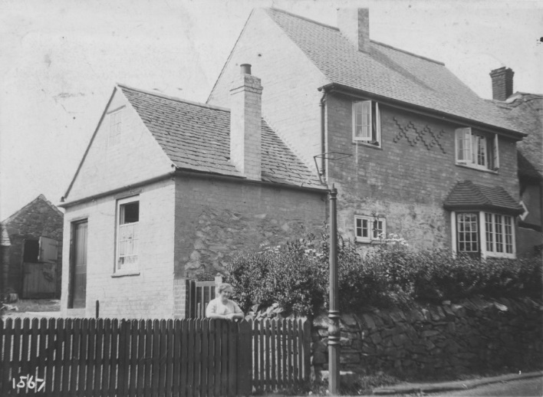

  - 15 Markfield Road
15 Markfield Road
Address | The Old Cottage, 15, Markfield Road, LE6 0FL | 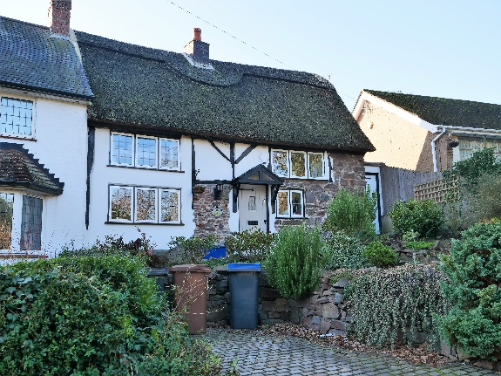
Grid Ref. | 452324, 307554
Asset Type | Building
Age | Unknown
Conservation Area | Yes
Selection Criteria
Value: Historic, Aesthetic-Architectural Interest
Significance: Group Value (1925 sale)
Description
This charming, timber framed, thatched cottage has one half of its front elevation built in stone and the other rendered. The property was once the home of the local Molecatcher who reputedly attempted to murder his wife.
Reason for Inclusion
Forms part of the Markfield Road cluster of historic buildings in Groby
Sources
- Identified as an unlisted building of local historic or architectural importance in HBBC Conservation Area Appraisal 2010.
- Appeared in ‘A Guided Tour’ by Groby Village Society.
- Recorded in the Leicestershire and Rutland HER (MLE15345).
- Part of Lot 89 ‘The Poplars Farm’ in 1925 sale.
- Nominated by respondents (2) to the community survey March 2022 as a building of local historic and aesthetic importance.
- There is a building at this location on the following OS maps:
  - OS Six Inch 1885 (Surveyed 1885) Leicestershire Sheet XXX. N.E.
  - OS Six Inch 1904 (Surveyed 1901) Leicestershire Sheet XXX. N.E.
  - OS Six Inch 1919 (Surveyed 1914) Leicestershire Sheet XXX. N.E.
  - OS Six Inch 1930 (Surveyed 1928) Leicestershire Sheet XXX. N.E.
Notes
- Main photograph by Andy Lincoln January 2022.
Additional Photographs
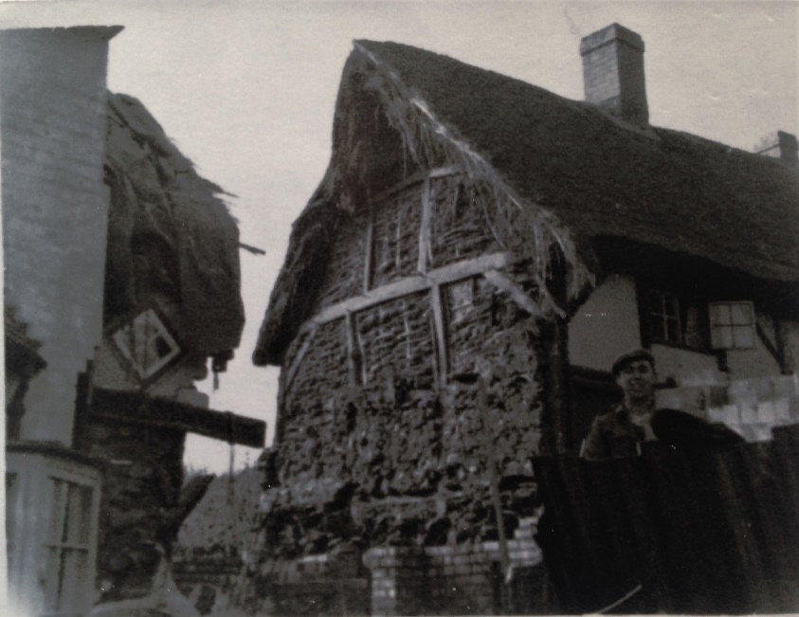 |  |  | 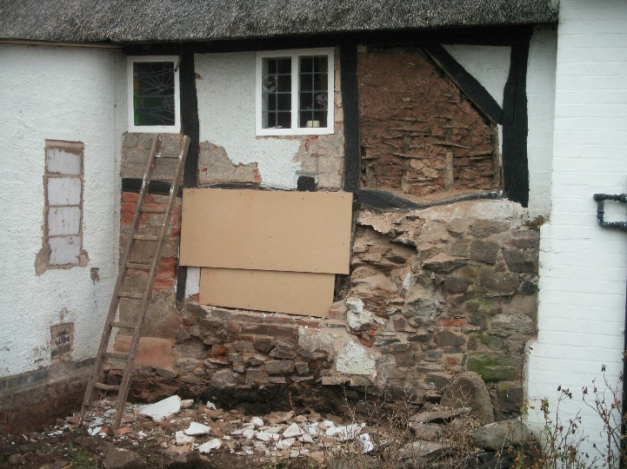

  - 33 Markfield Road
33 Markfield Road
Address | 33, Markfield Road, LE6 0FL | 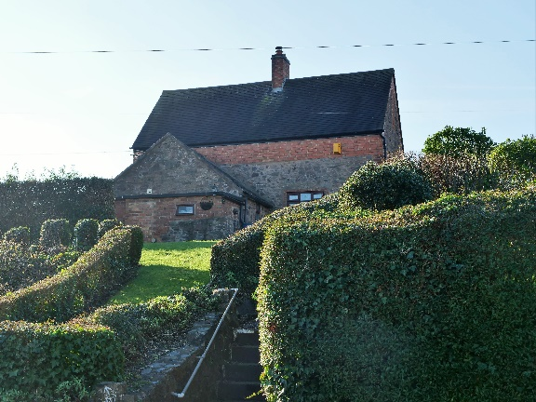
Grid Ref. | 452204, 307624
Asset Type | Building
Age | Unknown
Conservation Area | Yes
Selection Criteria
Value: Historic, Aesthetic-Architectural Interest
Significance: Group Value (1925 sale)
Description
This stone property had its roof raised in brick and was reroofed with a mixture of Groby slate and slate.
Reason for Inclusion
Forms part of the Markfield Road cluster of historic buildings in Groby
Sources
- Identified as an unlisted building of local historic or architectural importance in HBBC Conservation Area Appraisal 2010.
- Lot 110 in 1925 sale.
- Nominated by respondents (1) to the community survey March 2022 as a building of local historic importance.
- There is a building at this location on the following OS maps:
  - OS Six Inch 1885 (Surveyed 1885) Leicestershire Sheet XXX. N.E.
  - OS Six Inch 1904 (Surveyed 1901) Leicestershire Sheet XXX. N.E.
  - OS Six Inch 1919 (Surveyed 1914) Leicestershire Sheet XXX. N.E.
  - OS Six Inch 1930 (Surveyed 1928) Leicestershire Sheet XXX. N.E.
Notes
- Photographed by Andy Lincoln January 2022.

  - 35 Markfield Road
35 Markfield Road
Address | 35, Markfield Road, LE6 0FL | 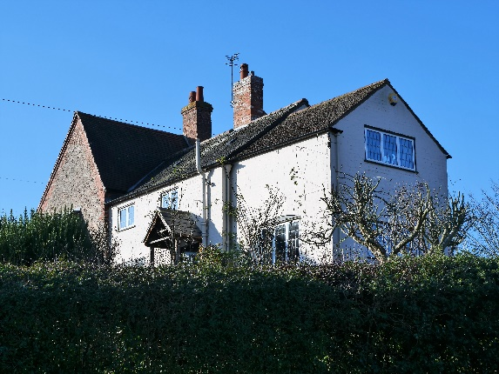
Grid Ref. | 452193, 307644
Asset Type | Building
Age | Unknown
Conservation Area | Yes
Selection Criteria
Value: Historic, Aesthetic-Architectural Interest
Significance: Group Value (1925 sale)
Description
This property occupies an elevated position on Markfield Road and is actually an amalgamation of four properties (35, 37, 39, and 41 Markfield Road). The brick part was added in 1901, the middle part was probably Victorian and the oldest part originally had a thatched roof. The property now has a Groby slate roof mixed with slate.
Reason for Inclusion
Forms part of the Markfield Road cluster of historic buildings in Groby
Sources
- Identified as an unlisted building of local historic or architectural importance in HBBC Conservation Area Appraisal 2010.
- Part of Lot 109 in 1925 sale.
- Nominated by respondents (1) to the community survey March 2022 as a building of local historic importance.
- There is a building at this location on the following OS maps:
  - OS Six Inch 1885 (Surveyed 1885) Leicestershire Sheet XXX. N.E.
  - OS Six Inch 1904 (Surveyed 1901) Leicestershire Sheet XXX. N.E.
  - OS Six Inch 1919 (Surveyed 1914) Leicestershire Sheet XXX. N.E.
  - OS Six Inch 1930 (Surveyed 1928) Leicestershire Sheet XXX. N.E.
Notes
- Photographed by Andy Lincoln January 2022.

  - 43 Markfield Road
43 Markfield Road
Address | 43, Markfield Road, LE6 0FL | 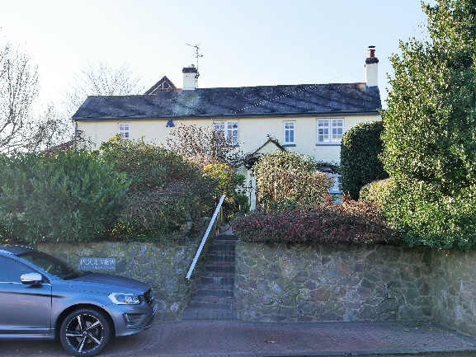
Grid Ref. | 452157, 307669
Asset Type | Building
Age | Unknown
Conservation Area | Yes
Selection Criteria
Value: Historic, Aesthetic-Architectural Interest
Significance: Group Value (1925 sale)
Description
This property has been considerably enlarged to its rear. The side dormer window, solar panels and plastic windows are not traditional features; fortunately, they are not too prominent from the highway. The property has a slate roof.
Reason for Inclusion
Forms part of the Markfield Road cluster of historic buildings in Groby
Sources
- Identified as an unlisted building of local historic or architectural importance in HBBC Conservation Area Appraisal 2010.
- Lot 108 in 1925 sale.
- Nominated by respondents (1) to the community survey March 2022 as a building of local historic importance.
- There is a building at this location on the following OS maps:
  - OS Six Inch 1885 (Surveyed 1885) Leicestershire Sheet XXX. N.E.
  - OS Six Inch 1904 (Surveyed 1901) Leicestershire Sheet XXX. N.E.
  - OS Six Inch 1919 (Surveyed 1914) Leicestershire Sheet XXX. N.E.
  - OS Six Inch 1930 (Surveyed 1928) Leicestershire Sheet XXX. N.E.
Notes
- Photographed by Andy Lincoln January 2022.

  - 57 Markfield Road
57 Markfield Road
Address | 57, Markfield Road, LE6 0FL | 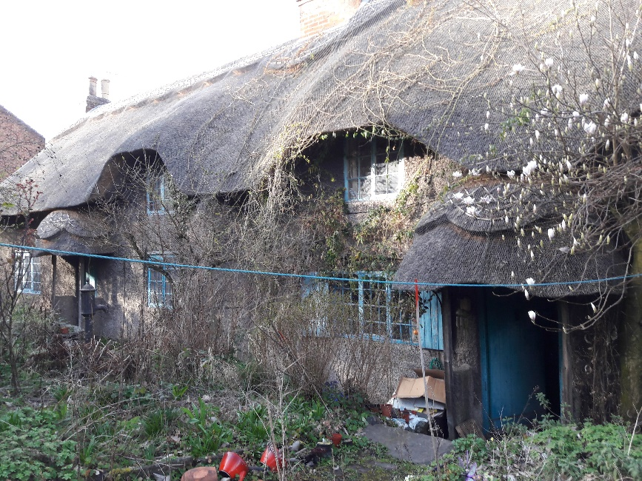
Grid Ref. | 452082, 307725
Asset Type | Building
Age | 1551
Conservation Area | Yes
Selection Criteria
Value: Historic, Aesthetic-Architectural Interest
Significance: Group Value (1925 sale)
Description
This property is a traditional thatched cottage that has its main elevation facing away from Markfield Road. Originally single storey, it was modified to two-storey. As well as thatch, some Groby slate and slate roofing.
Reason for Inclusion
Forms part of the Markfield Road cluster of historic buildings in Groby
Sources
- Identified as an unlisted building of local historic or architectural importance in HBBC Conservation Area Appraisal 2010.
- Recorded in the Leicestershire and Rutland HER (MLE15231).
- Lot 104 in 1925 sale.
- Nominated by respondents (2) to the community survey March 2022 as a building of local historic and aesthetic importance.
- There is a building at this location (shown as two plots) on the following OS maps:
  - OS Six Inch 1885 (Surveyed 1885) Leicestershire Sheet XXX. N.E.
  - OS Six Inch 1904 (Surveyed 1901) Leicestershire Sheet XXX. N.E.
  - OS Six Inch 1930 (Surveyed 1928) Leicestershire Sheet XXX. N.E.
- There is a building at this location (shown as one plot) on the following OS maps:
  - OS Six Inch 1919 (Surveyed 1914) Leicestershire Sheet XXX. N.E.
Notes
- Photographed by Alison Coates March 2019.

  - Home Farm
Home Farm
Address | Home Farm, Markfield Road, LE6 0FT | 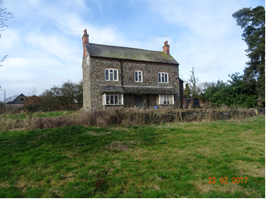
Grid Ref. | 451098, 308219
Asset Type | Building
Age | Unknown
Conservation Area | No
Selection Criteria
Value: Historic
Significance: Rarity – historic farmhouse
Description
A collection of buildings at Home Farm (under residential development)
Reason for Inclusion
Rare example of an historic farmhouse in a rural setting
Sources
- Identified by HBBC as part of a development proposal.
- Recorded in the Leicestershire and Rutland HER (MLE22635).
- Photograph DR 2017 before refurbishment.
- There is a building at this location (labelled as Bradgate Farm) on the following OS maps:
  - OS Six Inch 1885 (Surveyed 1885) Leicestershire Sheet XXX. N.E.
  - OS Six Inch 1904 (Surveyed 1901) Leicestershire Sheet XXX. N.E.
  - OS Six Inch 1919 (Surveyed 1914) Leicestershire Sheet XXX. N.E.
  - OS Six Inch 1930 (Surveyed 1928) Leicestershire Sheet XXX. N.E.
Notes
- contemporary photo needed.

  - Weighbridge, Home Farm
Weighbridge, Home Farm
Address | Home Farm, Markfield Road, LE6 0FT
Grid Ref. | 451097, 308256
Asset Type | Weighbridge
Age | 19th Century
Conservation Area | No
Selection Criteria
Value: Historic
Significance: Rarity
Description
Weighbridge at Home Farm.
Reason for Inclusion
The only known historic weighbridge in Groby
Sources
- Recorded in the Leicestershire and Rutland HER (MLE24127).
Notes
- contemporary photo needed.

  - Slate Wall, Markfield Road
Slate Wall, Markfield Road
Address | LE6 0FL |  | 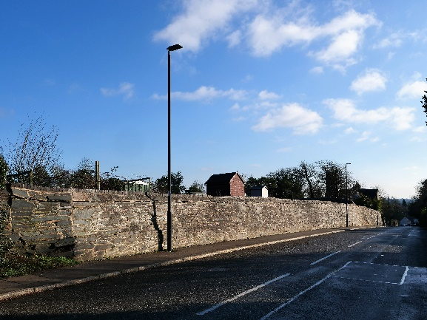
Grid Ref. | 452205, 307667
Asset Type | Slate Retaining Wall
Age | 1860
Conservation Area | Yes
Selection Criteria
Value: Historic, Aesthetic-Architectural Interest
Significance: Group Value
Description
Slate retaining wall on north side of Markfield Road from 30 Markfield Road towards A50 almost as far as Orchard Close Allotments entrance.
There should be a gas light with engraved slate plaque showing date of fixing light (DR)
Reason for Inclusion
The slate retaining wall is a key feature in the conservation area.
Sources
- Identified on the HBBC Conservation Area Appraisal 2010 Photographic Survey.
- Nominated by AJC July 2021.
- Nominated by David Ramsey 2022.
Notes
- Photographed by Andy Lincoln January 2022.
- Photographed by Mark 13/02/2022.
Additional Photographs
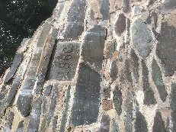 |  | 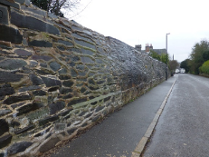

  - Stone Wall, Markfield Road
Stone Wall, Markfield Road
Address | LE6 0FL | 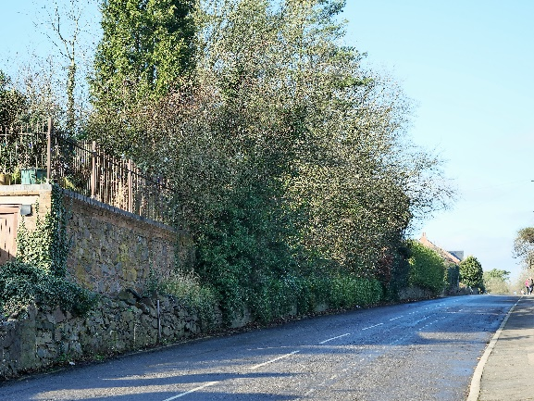
Grid Ref. | 452268, 307608
Asset Type | Stone Wall
Age | Unknown
Conservation Area | Yes
Selection Criteria
Value: Historic, Aesthetic-Architectural Interest
Significance: Group Value
Description
Traditional stone wall where Groby Mineral Line once crossed under the road.
Reason for Inclusion
The stone wall is a key feature in the conservation area.
Sources
- Identified on the HBBC Conservation Area Appraisal 2010 Photographic Survey.
- Nominated by AJC July 2021.
Notes
- Photographed by Andy Lincoln January 2022.

  - Wall in Orchard Close Allotment
Wall in Orchard Close Allotment
Address | LE6 0FL |  | 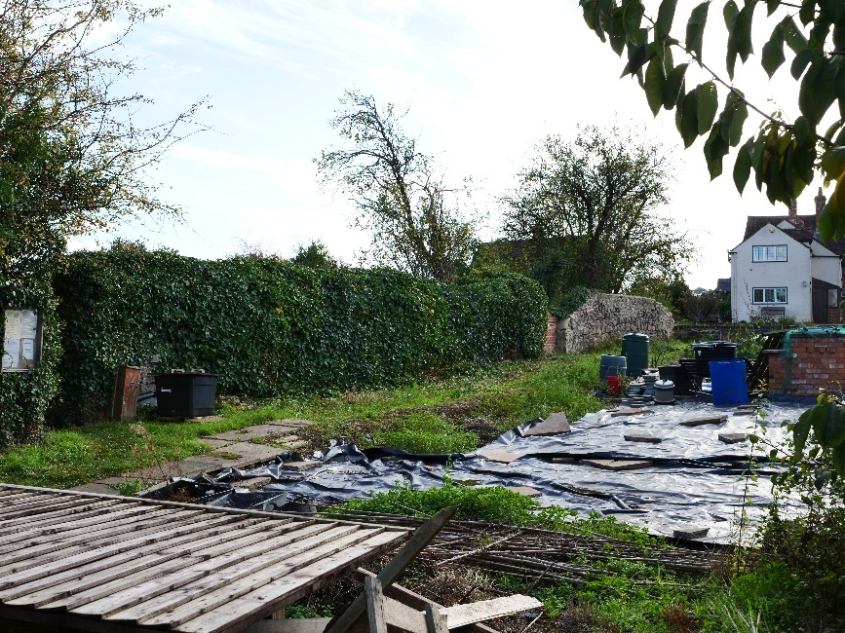
Grid Ref. | 452245, 307678
Asset Type | Stone Wall
Age | Unknown
Conservation Area | Yes
Selection Criteria
Value: Historic, Aesthetic-Architectural Interest
Significance: Group Value
Description
Remains of stone and brick wall
Reason for Inclusion
This wall is believed to be part of the Old Hall’s gardens.
Sources
- Identified on the HBBC Conservation Area Appraisal 2010 Photographic Survey.
Notes
- Photographed by Andy Lincoln October 2022.
Additional Photographs
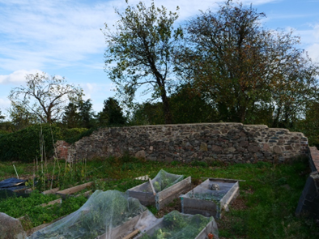 |  | 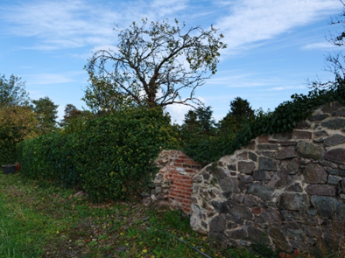 |  | 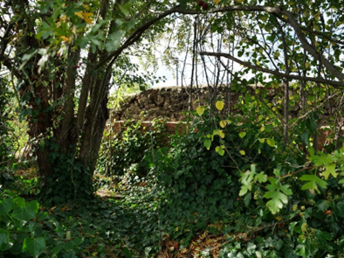
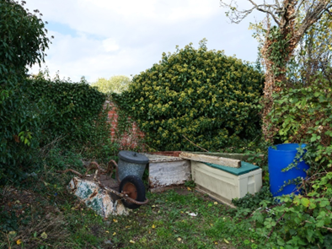 |  | 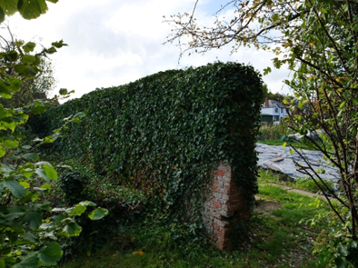

  - Groby Old Hall Outbuildings
Groby Old Hall Outbuildings
Address | Markfield Road, LE6 0FL | 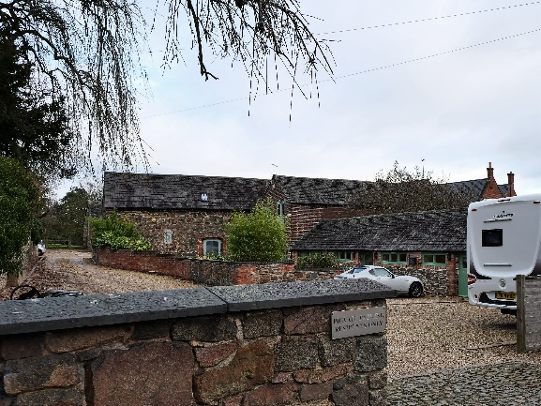
Grid Ref. | 452437, 307607 & 452427, 307573
Asset Type | Building
Age | Mid-19th Century
Conservation Area | Yes
Selection Criteria
Value: Historic
Significance: Group Value
Description
Renovated stone outbuildings with Groby slate roofs.
Reason for Inclusion
Mid-19th Century outbuildings, cow house, cart shed, barn
Sources
- Recorded in the Leicestershire and Rutland HER (MLE19752).
- There is a building at this location on the following OS maps:
  - OS Six Inch 1885 (Surveyed 1885) Leicestershire Sheet XXX. N.E.
  - OS Six Inch 1904 (Surveyed 1901) Leicestershire Sheet XXX. N.E.
  - OS Six Inch 1919 (Surveyed 1914) Leicestershire Sheet XXX. N.E.
  - OS Six Inch 1930 (Surveyed 1928) Leicestershire Sheet XXX. N.E.
Notes
- Photographed by Andy Lincoln January 2022.
- Probably included in the Old Hall listing.

  - Medieval wall west of Groby Old Hall
Medieval wall west of Groby Old Hall
Address | LE6 0FL | 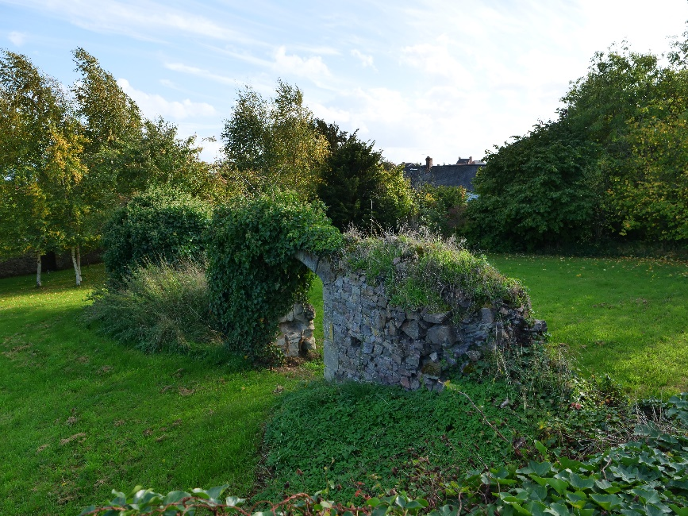
Grid Ref. | 452337, 307601
Asset Type | Building
Age | Medieval
Conservation Area | Yes
Selection Criteria
Value: Historic
Significance: Age, Group Value
Description
Remains of medieval stone wall
Reason for Inclusion
Forms part of medieval remains centred on Groby Old Hall
Sources
- Recorded in the Leicestershire and Rutland HER (MLE17580).
Notes
- Photographed by Andy Lincoln October 2022.
- Probably covered by the scheduled monument.
- Steering Group Meeting 25/08/2022 – probably covered by the scheduled monument – investigate again
Additional Photographs
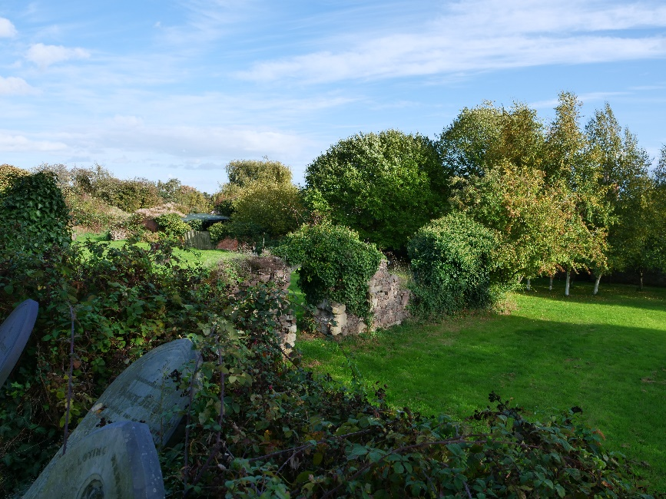

- Newtown Linford Lane
  - 11 Newtown Linford Lane
11 Newtown Linford Lane
Address | 11, Newtown Linford Lane, LE6 0EA | 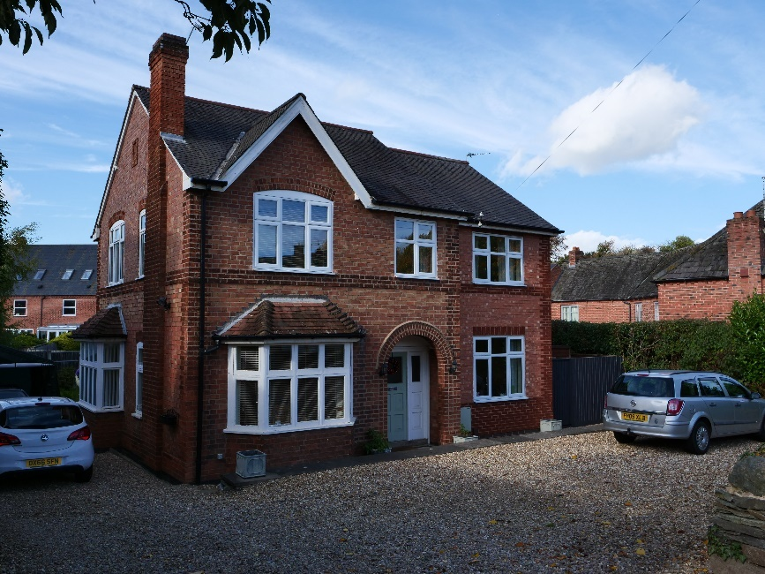
Grid Ref. | 452526, 307569
Asset Type | Building
Age | 1925-1928
Conservation Area | Yes
Selection Criteria
Value: Historic, Aesthetic-Architectural Interest
Significance: Group Value
Description
This property is a classic detached dwelling built in early C20 after the estate sale of 1925 that has had a recent side extension added. The property has a Groby slate roof.
Reason for Inclusion
Good example of an early C20 dwelling
Sources
- Identified as an unlisted building of local historic or architectural importance in HBBC Conservation Area Appraisal 2010.
- Nominated by David Ramsey 2022.
- There is a building at this location on the following OS maps:
  - OS Six Inch 1930 (Surveyed 1928) Leicestershire Sheet XXX. N.E.
Notes
- Photographed by Andy Lincoln October 2022.

  - Mill by Groby Pool
Mill by Groby Pool
Address | LE6 0FS
Grid Ref. | 452137, 308463
Asset Type | Building
Age | Unknown
Conservation Area | Yes
Selection Criteria
Value: Historic
Significance: Age, Rarity
Description
Remains of medieval watermill.
Reason for Inclusion
Rare example of medieval building separate from Groby Old Hall
Sources
- Recorded in the Leicestershire and Rutland HER (MLE2777).
- Nominated by AJC July 2021.
Notes
- contemporary photo needed.

- Rookery Lane
  - 20 Rookery Lane
20 Rookery Lane
Address | Holly Cottage, 20, Rookery Lane, LE6 0GL | 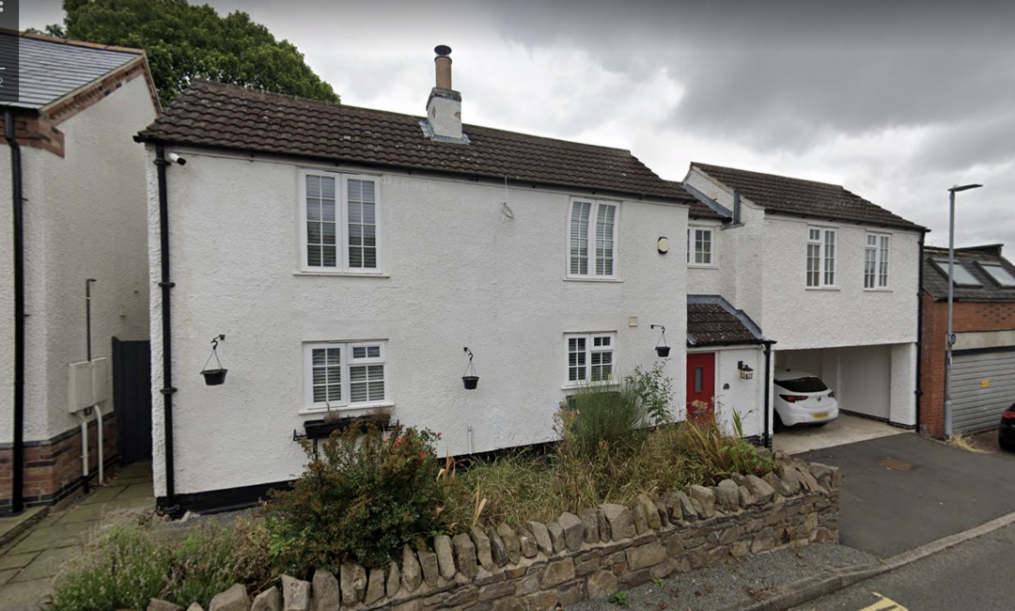
Grid Ref. | 452448, 307431
Asset Type | Building
Age | Unknown
Conservation Area | Yes
Selection Criteria
Value: Historic, Aesthetic-Architectural Interest
Significance: Group Value
Description
Clay roof.
Reason for Inclusion
Forms part of a cluster of historic buildings in Rookery Lane
Sources
- Identified as an unlisted building of local historic or architectural importance in HBBC Conservation Area Appraisal 2010.
- Recorded in the Leicestershire and Rutland HER (MLE21768).
- There is a building at this location on the following OS maps:
  - OS Six Inch 1885 (Surveyed 1885) Leicestershire Sheet XXX. N.E.
  - OS Six Inch 1904 (Surveyed 1901) Leicestershire Sheet XXX. N.E.
  - OS Six Inch 1919 (Surveyed 1914) Leicestershire Sheet XXX. N.E.
  - OS Six Inch 1930 (Surveyed 1928) Leicestershire Sheet XXX. N.E.
Notes
- Photo from Google Earth October 2022.
Additional Photographs
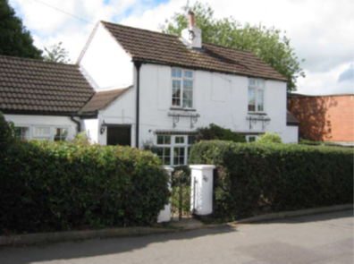
Photo from Conservation Area Appraisal 2010

  - 24 Rookery Lane Outbuilding
24 Rookery Lane Outbuilding
Address | 24, Rookery Lane, LE6 0GL | 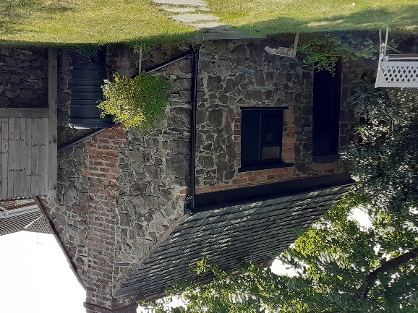
Grid Ref. | 452447, 307391
Asset Type | Building
Age | Unknown
Conservation Area | Yes
Selection Criteria
Value: Historic
Significance: Group Value
Description
Stone built with Groby slate roof.
Reason for Inclusion
Vernacular architecture. Forms part of a cluster of historic buildings in Rookery Lane.
Sources
- Recorded in the Leicestershire and Rutland HER (MLE21769).
- There is a building at this location on the following OS maps:
  - OS Six Inch 1885 (Surveyed 1885) Leicestershire Sheet XXX. N.E.
  - OS Six Inch 1904 (Surveyed 1901) Leicestershire Sheet XXX. N.E.
  - OS Six Inch 1919 (Surveyed 1914) Leicestershire Sheet XXX. N.E.
  - OS Six Inch 1930 (Surveyed 1928) Leicestershire Sheet XXX. N.E.
Notes
- Photographed by Anita Mullins September 2022.
Additional Photographs
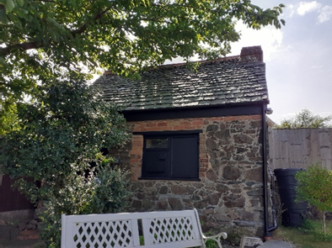 |  |  | 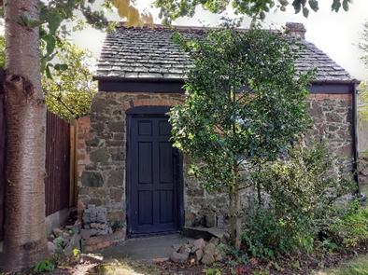

- Stephenson Way
  - Wharf Cottage
Wharf Cottage
Address | Wharf Cottage, 26, Stephenson Way, LE6 0FW | 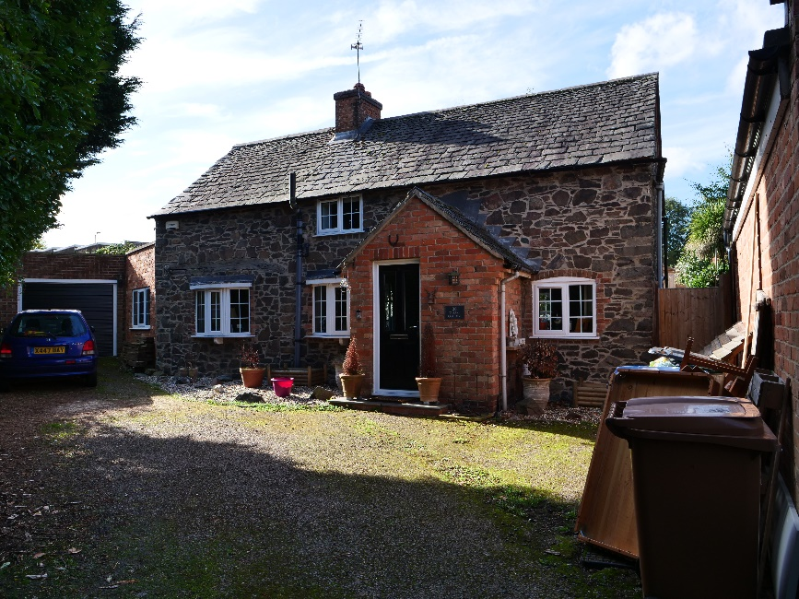
Grid Ref. | 452178, 307476
Asset Type | Building
Age | c. 1895
Conservation Area | No
Selection Criteria
Value: Historic, Aesthetic-Architectural Interest
Significance: Group Value (Quarrying)
Description
Stone built with Groby slate roof.
Reason for Inclusion
Towards the bottom of Ratby Road on the left was the entrance to the quarry and the railway line around the (railway) wharf were some large brick buildings including the engine shed.
Sources
- GPC submitted in 2014 to HBBC Register of Local Heritage Assets (although incorrectly identified as Ratby Road).
- Groby and its Railways 1982 David Ramsey
- There is a building at this location on the following OS maps:
  - OS Six Inch 1885 (Surveyed 1885) Leicestershire Sheet XXX. N.E.
  - OS Six Inch 1904 (Surveyed 1901) Leicestershire Sheet XXX. N.E.
  - OS Six Inch 1919 (Surveyed 1914) Leicestershire Sheet XXX. N.E.
  - OS Six Inch 1930 (Surveyed 1928) Leicestershire Sheet XXX. N.E.
Notes
- GPC incorrectly identified location as Ratby Road
- Photographed by Andy Lincoln October 2022.

  - 22 & 24 Stephenson Way
Quarry Manager’s House
Address | 22 & 24 Stephenson Way, LE6 0FW | 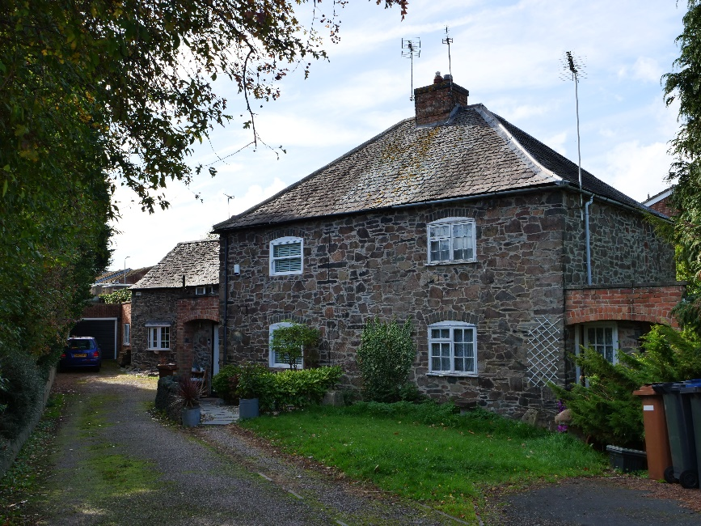
Grid Ref. | 452184, 307422
Asset Type | Building
Age | c. 1895
Conservation Area | No
Selection Criteria
Value: Historic, Aesthetic-Architectural Interest
Significance: Group Value (Quarrying)
Description
Stone built with Groby slate roof.
Reason for Inclusion
Towards the bottom of Ratby Road on the left was the entrance to the quarry and the railway line around the (railway) wharf were some large brick buildings including the engine shed.
Sources
- Groby and its Railways 1982 David Ramsey
- There is a building at this location on the following OS maps:
  - OS Six Inch 1885 (Surveyed 1885) Leicestershire Sheet XXX. N.E.
  - OS Six Inch 1904 (Surveyed 1901) Leicestershire Sheet XXX. N.E.
  - OS Six Inch 1919 (Surveyed 1914) Leicestershire Sheet XXX. N.E.
  - OS Six Inch 1930 (Surveyed 1928) Leicestershire Sheet XXX. N.E.
Notes
- Photographed by Andy Lincoln October 2022.

- White House Close
  - The White Cottage
The White Cottage
Address | The White Cottage, White House Close, LE6 0GW | 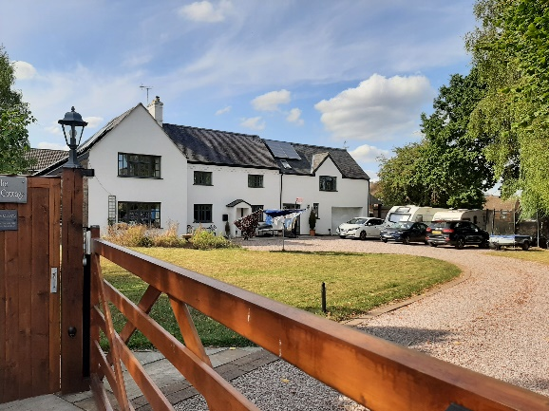
Grid Ref. | 452288, 307069
Asset Type | Building
Age | Unknown
Conservation Area | No
Selection Criteria
Value: Historic
Significance: Group Value (1925 sale)
Description
Two-storey dwelling with slate roof.
Reason for Inclusion
Part of the 1925 sale now surrounded by a modern housing estate
Sources
- Lot 138 ‘Cowpen Cottage’ in 1925 sale.
- Nominated by respondents (5) to the community survey March 2022 as a building of local historic, aesthetic, and group value importance.
- There is a building at this location on the following OS maps:
  - OS Six Inch 1885 (Surveyed 1885) Leicestershire Sheet XXX. N.E.
  - OS Six Inch 1904 (Surveyed 1901) Leicestershire Sheet XXX. N.E.
  - OS Six Inch 1919 (Surveyed 1914) Leicestershire Sheet XXX. N.E. (labelled as Cowpen Cottage)
  - OS Six Inch 1930 (Surveyed 1928) Leicestershire Sheet XXX. N.E. (labelled as Cowpen Cottage)
Notes
- Photographed by Carol Lincoln September 2022.

- Miscellaneous
  - Groby Granite Railway
Groby Granite Railway
Address | Groby | 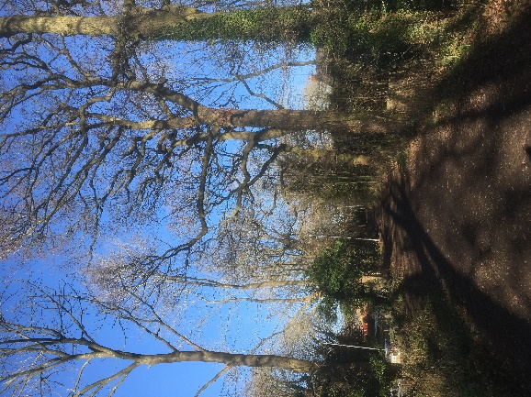
Grid Ref. | NA
Asset Type | Old Railway
Age | 1832
Conservation Area | Partly
Selection Criteria
Value: Historic, Community
Significance: Rarity, Landmark Quality, Group Value (Quarrying)
Description
Little remains to indicate the location of the old railway built by the Earl of Stamford in 1832 to link his quarries with the Leicester to Swannington railway at Glenfield. The line was surveyed and built by George Stephenson and his son Robert. It was a gravity line and empty wagons went up by horse then cable. After 1860 the wagons were taken by steam locomotive to connect with the main good trains. This route is now enjoyed as open space and a general-purpose path from the Ratby Road Allotments entrance to Sacheverell Way.
Groby Granite Company added a railway from the quarries in the centre of the village to the quarries north of the village in 1860. This route is now enjoyed through a combination of public footpath, permissive path, and the Groby Pool Nature Area (Dowry Furlong).
Reason for Inclusion
Route of one of the oldest railways now enjoyed for recreation.
Sources
- Identified as an unlisted building of local historic or architectural importance in HBBC Conservation Area Appraisal 2010.
- ‘A Guided Tour’ by Groby Village Society.
- Groby and its Railways 1982 David Ramsey
- GPC submitted in 2014 to HBBC Register of Local Heritage Assets (although only south of Oaktree Close was included).
- Recorded in the Leicestershire and Rutland HER (MLE16161) as Groby Mineral Railway (the whole length).
- Nominated by respondents (26) to the community survey March 2022 as a feature of local historic importance.
Notes
- Main photograph by Mark Griffin January 2022.
Additional Photographs
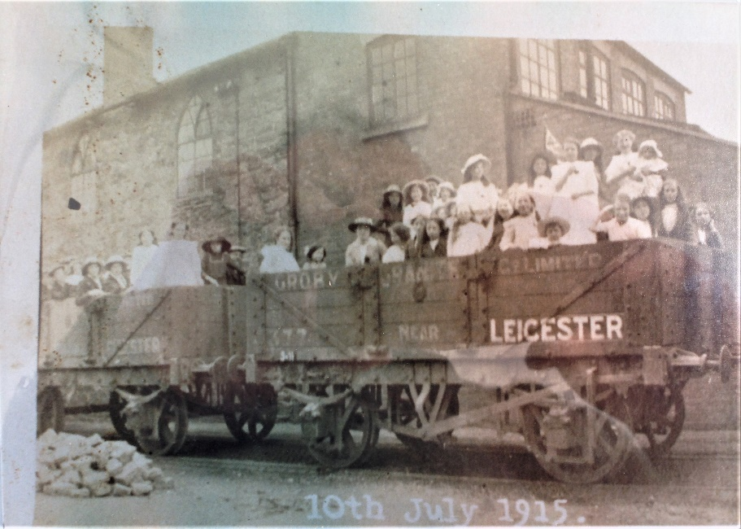 |  |  | 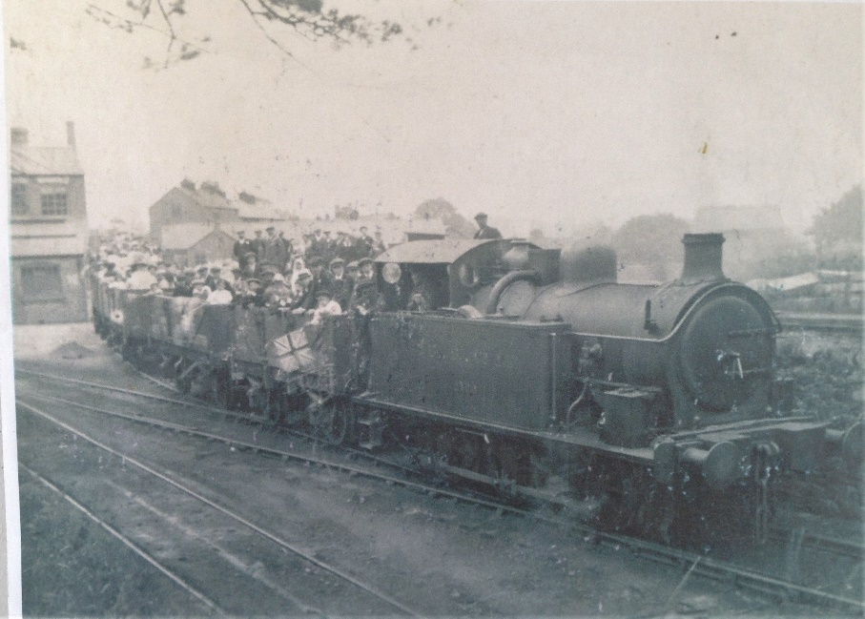

  - Memorial on Stamford Memorial Park
Memorial on Stamford Memorial Park
Address | Groby |  | 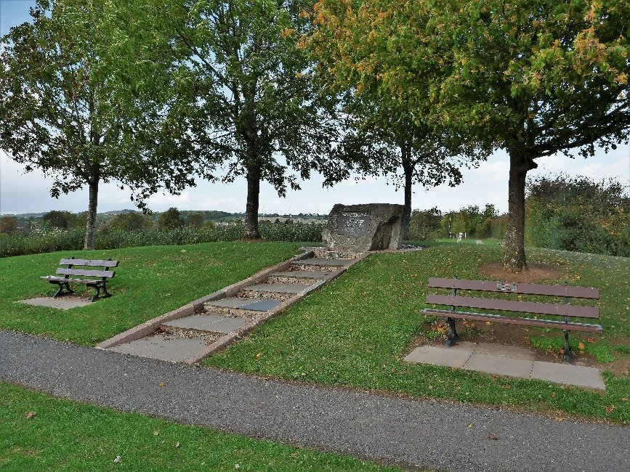
Grid Ref. | 453130, 306877
Asset Type | Memorial
Age | 2008
Conservation Area | No
Selection Criteria
Value:
Significance:
Description
Stamford Memorial Park was named to commemorate five young men, members of the Stamford Arms football team, who died in a road accident on a Christmas outing in 1998. A granite memorial was built in the north-eastern corner of the park in 2008. There are five benches nearby, named for each man.
Reason for Inclusion
Poignant reminder of the single most tragic accident to occur in Groby’s history.
Sources
- Nominated by a respondent (1) to the community survey March 2022 as a feature of local historic importance.
Notes
- Photographed by Andy Lincoln October 2022.
Additional Photographs
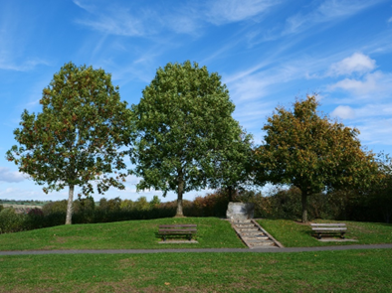 |  | 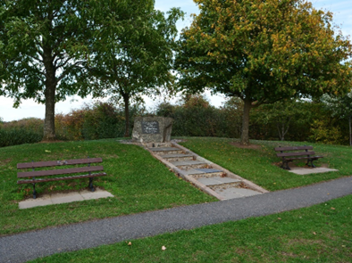 |  | 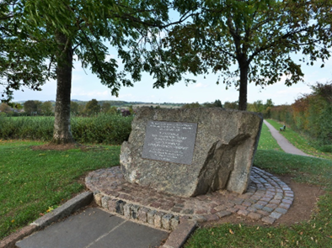
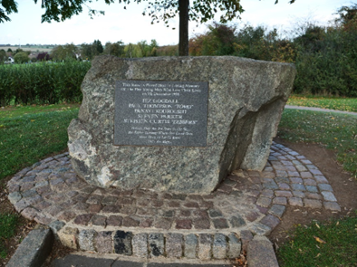 |  | 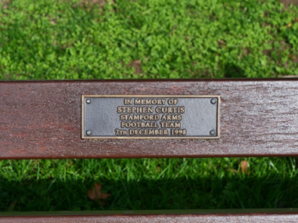 |  | 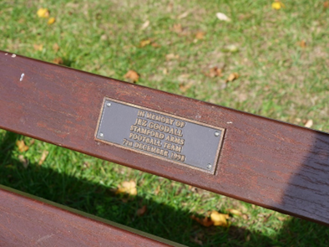
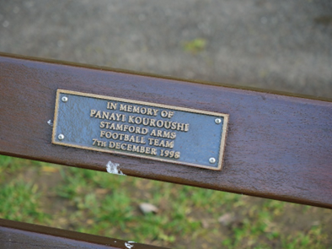 |  | 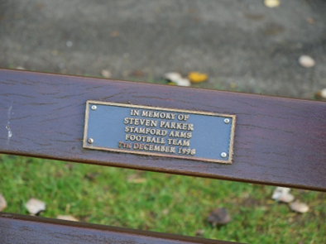 |  | 