LOCAL GREEN SPACE DESIGNATION

A TOOLKIT FOR COMMUNITIES PREPARING NEIGHBOURHOOD PLANS

Step 2: Complete checklist
If it seems that the candidate site may meet the designation criteria, complete the designation checklist below (and provide all the relevant evidence). The checklist should be completed for each candidate site.
1 | General Information
1.1 | Name and address of site  Some sites have several names and all known names should be given
Queen Elizabeth II XC Park

(Known to HBBC as Meadow Way Amenity Green Space)
1.2 | Site location plan  The plan can be at any scale, but must show the location and boundaries of the site.  Please indicate the scale.
 | Attached
1.3 | Organisation or individual proposing site for designation  This will normally be a Town or Parish Council or a recognised community group
 | Groby Parish Council
1.4 | Ownership of site if known  Information on land ownership can be obtained from the Land Registry. Some land parcels are not registered however local people may know the owner.
 | Groby Parish Council
1.5 | Is the owner of the site aware of the potential designation?
 | The owners will be made aware through pre-submission consultation
1.6 | Does the owner support the designation?  Sites may be designated as Local Green Spaces, even if there are objections from the site owners
 | The owners will be made aware through pre-submission consultation
1.7 | Photographs of site
 | Attached
1.8 | Community served by the potential Local Green Space  i.e. does the site serve the whole village/town or a particular geographic area or group of people?
 | The site serves mainly the east of Groby village but is very well-connected to all areas of the village.
2 | Planning History
2.1 | Is there currently a planning application for this site? If planning permission has been permitted could part of the overall site still be used as a Green Open Space?
 | No
2.2 | Is the site allocated for development in the Local Plan? If allocated, could part of the overall site still be used as a Green Open Space?
 | No
3 | Size, scale and “local nature” of proposed Local Green Space
3.1 | Area of proposed site  It is unlikely that a site of over 20ha (50 acres) would be considered suitable for designation.
 | 1.01 hectare
3.2 | Is the site an “extensive tract of land”?  (Extensive tracts of land cannot be designated as Local Green Space)  e.g. how large is it in comparison to other fields; groups of fields; areas of land in the vicinity etc.? Does the site “feel” extensive or more local in scale?
 | No
3.3 | Is the proposed site “local in character”?  e.g. does the site feel as though it is part of the local area? And why? How does it connect physically, visually and socially to the local area? What is your evidence?
The site is well-connected to the surrounding residential area and may be accessed on foot from Sycamore Drive (LE6 0EW), Meadow Way (LE6 0EY), and Meadow Court Road (LE6 0DW). A public footpath (R40) crosses the park from north to south.

The open grassed space provides a visual respite from the surrounding residential development.
4 | Need for Local Green Space
4.1 | Is there a need for a local green space in this location?  e.g. is there a shortage of accessible greenspace in the area? Is there a village needs survey or parish plan that provides evidence of that need. Further information – Natural England (Accessible Natural Greenspace Standard)
 | Yes. The nearest accessible natural green space larger than 2 hectares is more than 300 m (5 minutes) walk away.
5 | Evidence to show that “the green space is in reasonably close proximity to the community it serves”
5.1 | How far is the site from the community it serves? Is the site within 2km of the local community?  Possible evidence – a map to show that distance
 | The nearest residences are in Groby village adjacent to all sides of the site. All Groby village residences are less than 1.4 km away. Bradgate Hill hamlet is less than 1.8 km away. The Brantings are less than 1.3 km away. Field Head is 4.0 km away.
5.2 | Are there any barriers to the local community accessing the site from their homes?  e.g. railway line; main road  Possible evidence – a map to show any potential barriers and how those can be overcome.
 | No
6 | Evidence to show that the green area is “demonstrably special to a local community”
6.1 | Evidence of support from Parish or Town Council  e.g. letter of support; Council minutes
Identified as LGS in Pre-Submission Neighbourhood Plan.

Groby Parish Council registered the site with Fields in Trust in June 2017.
6.2 | Evidence of support from other local community groups or individuals.  e.g. letters of support; petitions; surveys etc.
 | 69.5% of respondents to our 2022 Community Survey supported LGS designation
6.3 | Evidence of support from community leaders  e.g. letters of support from Ward Members; County Councillors; MP etc.
 | None
6.4 | Evidence of support from other groups  e.g. letters of support from organisations such as Campaign to Protect Rural England; local amenity societies; local schools etc.
 | None
7 | Evidence to show that the green area “holds a particular local significance, for example because of its beauty,” (if applicable)
7.1 | Is this criteria relevant to this site?
 | No
7.2 | Describe why the community feels that the site has a particular local significance for its beauty.
 | No
7.3 | Site visibility  e.g. is it easy to see the site from a public place? Are there long-distance views of the site? Are there views of the site from any key locations?
 | No
7.4 | Is the site covered by any landscape or similar designations?  e.g. Area of Outstanding Natural Beauty; Conservation Area; Special Landscape Area  Further information –Natural England
 | No
7.5 | Is the site (or the type of site) specifically mentioned in any relevant landscape character assessments or similar documents?  Further information –Natural England
 | The site lies in the Charnwood Forest Regional Park.
7.6 | Does the site contribute to the setting of a historic building or other special feature?
 | No
7.7 | Is the site highlighted in literature or art?  e.g. is the site mentioned in a well-known poem or shown in a famous painting?
 | No
8 | Evidence to show that the green area “holds a particular local significance for example because of its historic significance” (if applicable)
8.1 | Is this criteria relevant to this site?
 | Yes
8.2 | Are there any historic buildings or remains on the site?  e.g. listed buildings; scheduled ancient monuments; registered parks and gardens; war memorials; other historic remains or structures.  Further information –English Heritage; local history society
Yes. An oak has been planted in 2020 to commemorate the 400-year anniversary of the Sacheverell Trust.

The park was named to commemorate Queen Elizabeth II’s 90th birthday in 2016.
8.3 | Are there any important historic landscape features on the site?  e.g. old hedgerows; ancient trees; historic ponds or historic garden features  Further information –English Heritage; local history society
Yes. At the north end of the site there is evidence of ridge and furrow earthworks that are now very rare in Groby Parish. The agricultural system that led to the earthworks is clearly seen in Doharty’s 1757 map.

Some of the current boundaries are shown as furlong boundaries in Doharty’s 1757 map and as a hedge in the OS Six Inch 1885 (Surveyed 1885) Leicestershire Sheet XXX. N.E. map. The remaining hedges appear to be at least 135 years old.
8.4 | Did the site play an important role in the historic development of the village or town?  e.g. the old site of the town railway station; the old garden for the manor house etc.
 | No
8.5 | Did any important historic events take place on the site?
 | No
8.6 | Do any historic rituals take place on the site?  e.g. well-dressing; maypole dancing etc.
 | No
9 | Evidence to show that the green area “holds a particular local significance, for example because of its recreational value (including as a playing field)”, (if applicable)
9.1 | Is this criteria relevant to this site?
 | Yes
9.2 | Is the site used for playing sport?  If so what sport? How long has it been used for sports provision? Is this sports provision free or is a club membership required?  Further information – Sport England
 | No
9.3 | Are the public able to physically access the site?  e.g. are there any public rights of way across the site? Or adjacent to the site? Has access been allowed on a discretionary basis? Is there public access to the whole site or only part? Is there good disabled access to the site? (A site can still be designated even if there is no public access.)
 | Yes, there is unrestricted public access to the whole site. A public footpath (R40) crosses the park from north to south.
9.4 | Is the site used by the local community for informal recreation? And since when?  e.g. dog walking; sledging; ball games etc.
 | Yes. There is a wooden agility trail intended for all ages. The site is popular for walking (including dog walking).
10 | Evidence to show that the green area “holds a particular local significance, for example because of its tranquillity” (if applicable)
10.1 | Is this criteria relevant to this site?
 | No
10.2 | Do you consider the site to be tranquil?  e.g. are there are any roads or busy areas close by?
 | No
10.3 | Is the site within a recognised tranquil area?  e.g. within the Campaign to Protect Rural England‟s tranquillity maps
 | No
11 | Evidence to show that the green area “holds a particular local significance, for example because of the richness of its wildlife”; (if applicable)
11.1 | Is this criteria relevant to this site ?
 | Yes
11.2 | Is the site formally designated for its wildlife value?  e.g. as a site of special scientific interest; a key wildlife site etc Further information - Natural England
 | No
11.3 | Are any important habitats or species found on the site?  e.g. habitats and species listed in the UK priority habitats and species lists or in Biodiversity Action Plans or protected species or on the red/amber lists of birds of conservation concern.  Further information - Natural England; National Biodiversity Network; RSPB
Some of the current boundaries are shown as furlong boundaries in Doharty’s 1757 map and as a hedge in the OS Six Inch 1885 (Surveyed 1885) Leicestershire Sheet XXX. N.E. map. The remaining hedges appear to be at least 135 years old and provides an important wildlife habitat.

There has been much recent tree planting.
11.4 | What other wildlife of interest has been found on the site?  Further information - Natural England; National Biodiversity Network
 | None
11.5 | Is the site part of a long term study of wildlife by members of the local community?  e.g. long-term monitoring of breeding birds.
 | No
12 | Evidence to show that the green area “holds a particular local significance, for any other reason”; (if applicable)
12.1 | Is this criteria relevant to this site?
 | No
12.2 | What are the other reasons why the site has a particular local significance for the local community?
 | No

Step 3: Neighbourhood Plan Group considers designation
The Neighbourhood Plan Group should review the evidence provided and decide whether the site is suitable for designation and whether any additional evidence is required.
Not every potential site will meet every criterion, however all sites must meet the following criteria in the checklist -
2.1 | not with an extant planning permission within which the Local Green Space could not be accommodated
2.2 | not allocated for development in the relevant Neighbourhood Plan, unless it can be shown that the Local Plan housing allocation is not strategic and can be re-located somewhere else in the neighbourhood plan area; or alternatively that the Local Green Space could be incorporated within the site as part of the allocated development
3.2 | Not an “extensive tract of land”
3.3 | “local in character”
5 | in “proximity to the community it serves”
6 | “demonstrably special to the local community”

And all sites must meet at least one of the following criteria in the Checklist -
7 | “particular local significance … because of its beauty”
8 | “particular local significance … because of its historic significance”
9 | “particular local significance … because of its recreational value”
10 | “particular local significance … because of its tranquillity”
11 | “particular local significance … because of its wildlife”
12 | “particular local significance … for any other reason”

In order to provide greater certainty, the checklist incorporates Natural England’s Accessible Natural Greenspace Standards (ANGSt) to define the likely size of a suitable Local Green Space and its distance from the local community.
A site of over 20ha (50 acres) is considered to be “an extensive tract of land” and therefore not suitable for designation as a Local Green Space.
If during the process it becomes evident that the site is not appropriate for local green space designation, there are other options that can be investigated (see Appendix 2).

Step 4: Consult landowner
The Neighbourhood Plan Group should consult the landowner.

Step 5: Neighbourhood Plan Designation
The site can now be designated in the Neighbourhood Plan. The site designation will be “tested” through the plan process. Anybody can object to policies or sites in a plan during the consultation process and these consultation responses must be considered.
The Neighbourhood Plan will be scrutinised by an Independent Examiner, who will ensure that the plan is robust and based on sound evidence. The completed checklist will form part of that evidence. The Neighbourhood Plan will also be subject to a local referendum.
Formal designation will be complete when the Neighbourhood Plan is ‘made’.

APPENDIX 1: MODEL NEIGHBOURHOOD PLAN POLICY AND SUPPORTING TEXT

Draft Supporting Text
National policy makes provision for local communities to identify green areas of particular importance to those communities, where development will not be permitted except in very special circumstances. The following sites have been designated as Local Green Spaces through the Neighbourhood Plan consultation process:

Draft Policy
Development that would harm the openness or special character of a Local Green Space (as designated on the Polices Map) or its significance and value to the local community will not be permitted unless there are very special circumstances which outweigh the harm to the Local Green Space.

APPENDIX 2: ALTERNATIVES TO LOCAL GREEN SPACE DESIGNATION

Agreements with land-owners
It may be possible for local communities to reach either formal or informal agreements with the owner of the site to ensure access to the site for local people. This may be an appropriate option where the site owner has a long-term connection with the local area, for example the owner of a large historic estate. It may be possible for the land-owner to dedicate the site as “open access land”.
Further information:
Right of way and open access land - GOV.UK

Community Purchase
In some instances local communities have purchased important sites to ensure that they remain in community control in perpetuity. The ownership can lie with the Town or Parish Council or with a specific trust.

Village Green status
Anyone can apply to register land as a green if it has been used by local people for lawful sports and pastimes ‘as of right’ (i.e. without permission, force or secrecy) for at least 20 years.
Further information:
Town and village greens: how to register Open Spaces Society

Local Nature Reserves
A Local Nature Reserve (LNR) provide people with special opportunities to study or learn about nature or simply to enjoy it. Local Nature Reserves are designated by district or county councils and the Local Authority must control the LNR through ownership, lease or agreement with the owner.
Further information:
Natural England

Assets of Community Value
The Community Right to Bid gives community groups a fairer chance to prepare and bid to buy community buildings and facilities that are important to them. This could include village shops, pubs or allotments. The right covers private as well as public assets. It is important to nominate land and buildings to be part of the register of ‘assets of community value’, which is held by the Local Authority. If something on this register is offered for sale, the community then have up to six months to prepare a bid.
Further information:
www.gov.uk My Community Rights

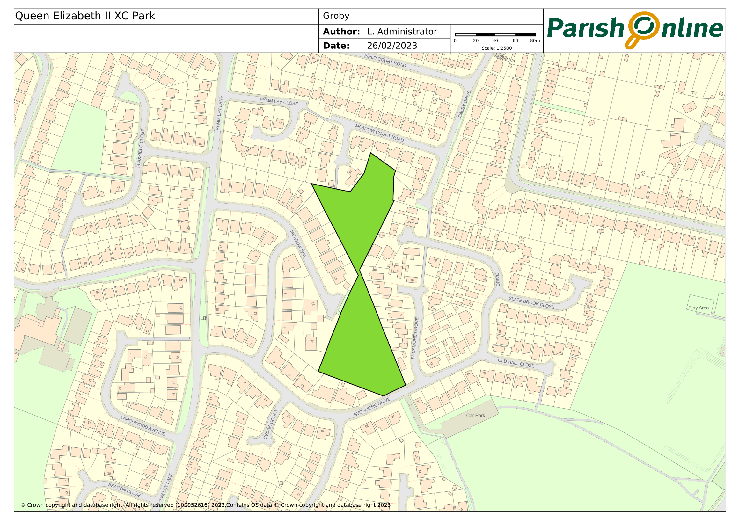

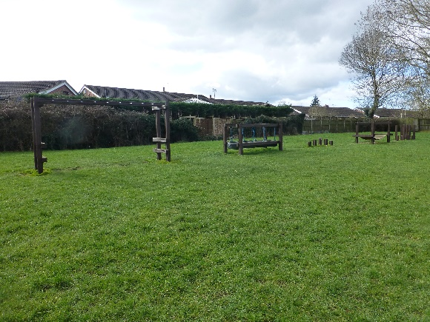 | 